\\saueazfsq01\bnz-datamanagement-team\Source

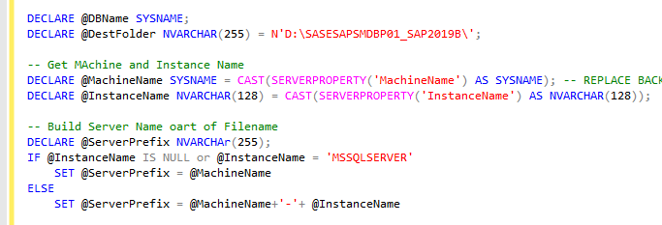

**14 July 2025 - Change Task- CTASK2517494 (CR-CHG000800996)**

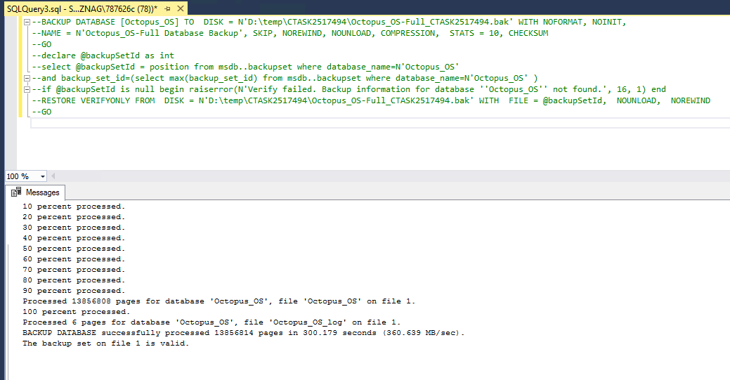

CHG000803800 (ADM Customized Reporting) – 16 July 2025

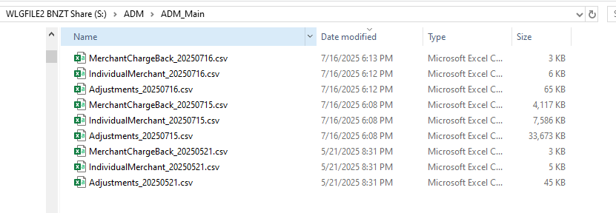

**DASD-2410 (ADM - Reporting - remove email Dan Park from ADM Merchant Job)**

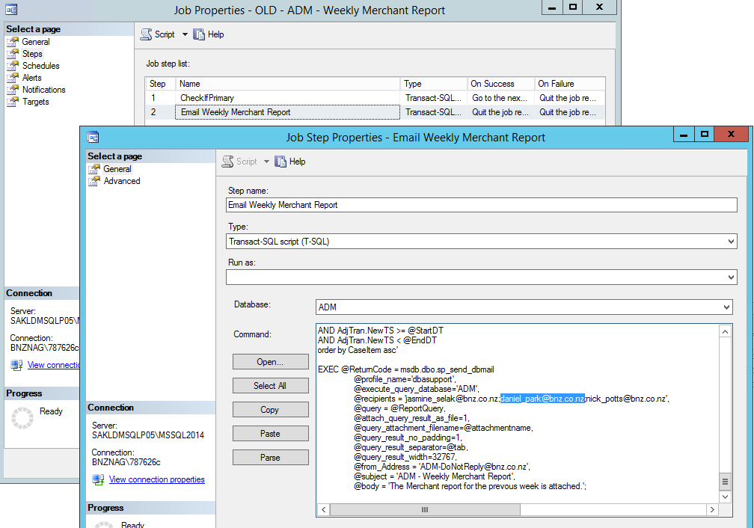

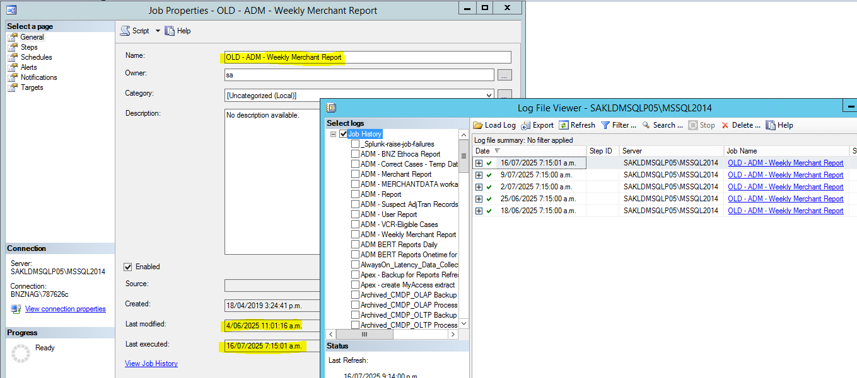

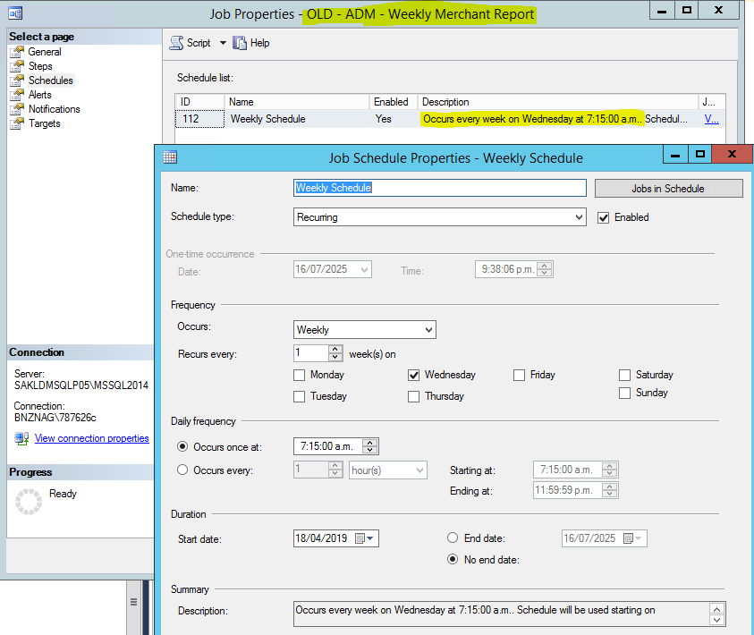

**CHG000803071 ( CTASK2526308 ( SQL Change ) - APEX - CC/PL Auto decisioning Enhancement – 17 July 2025**

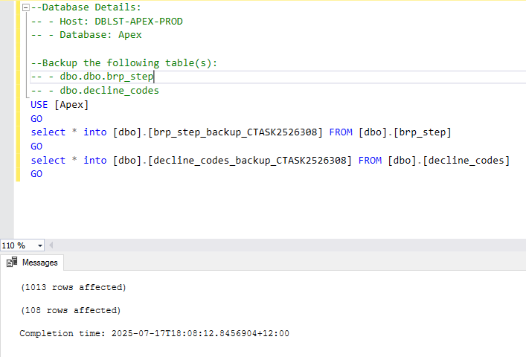

**SAP SQL server - Patching 17 July 2025**

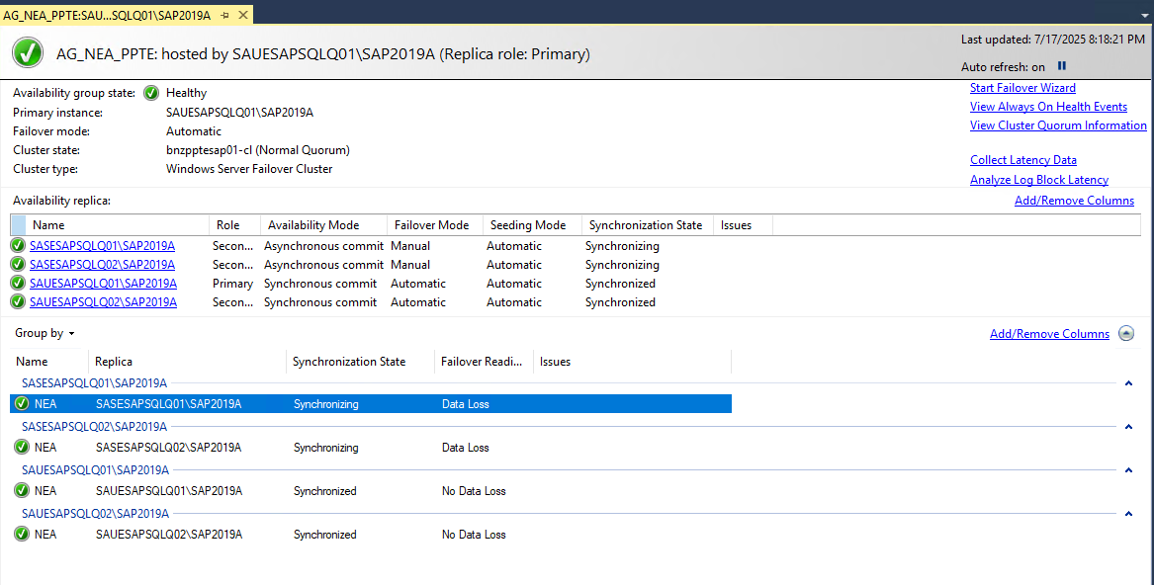

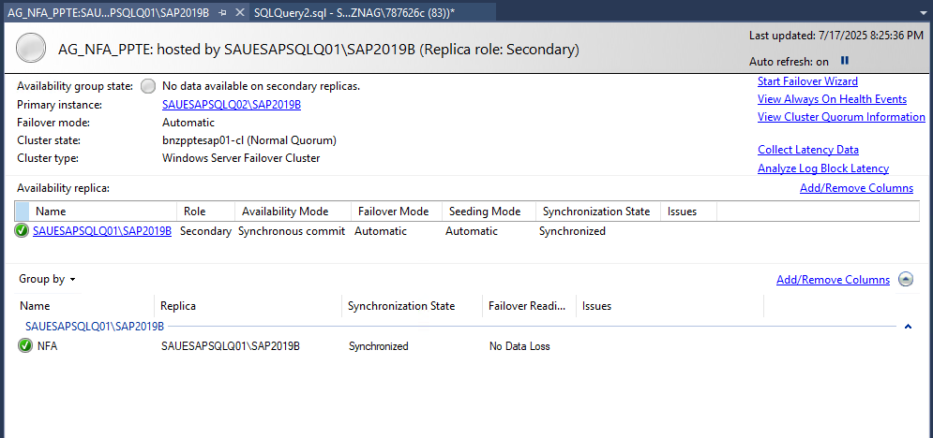

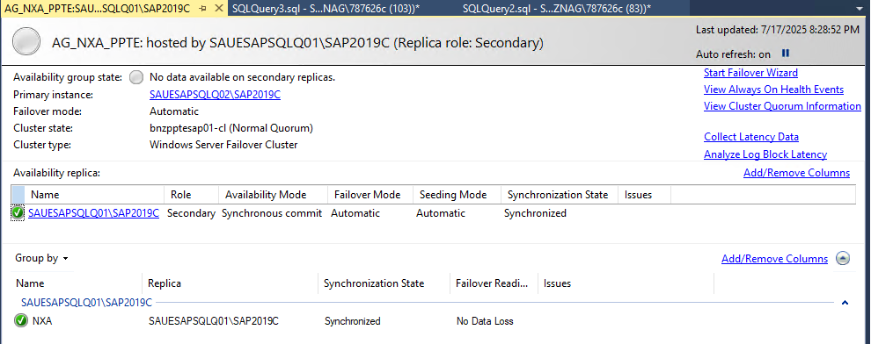

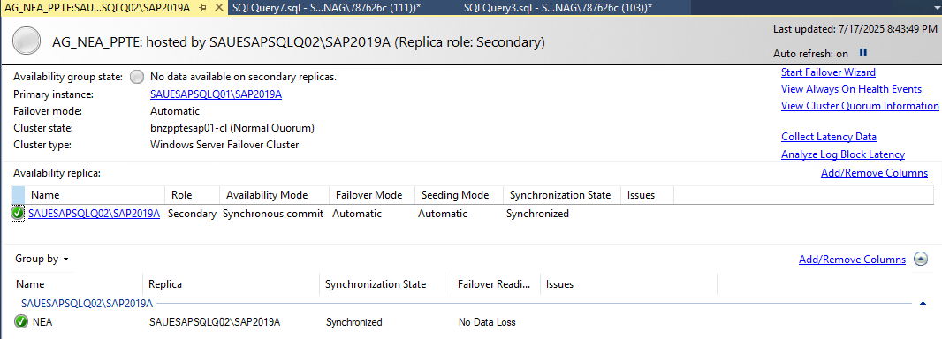

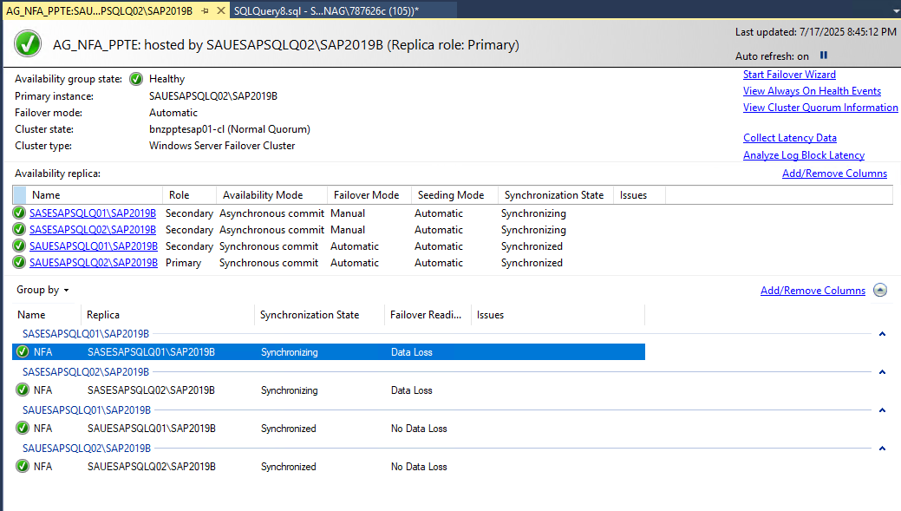

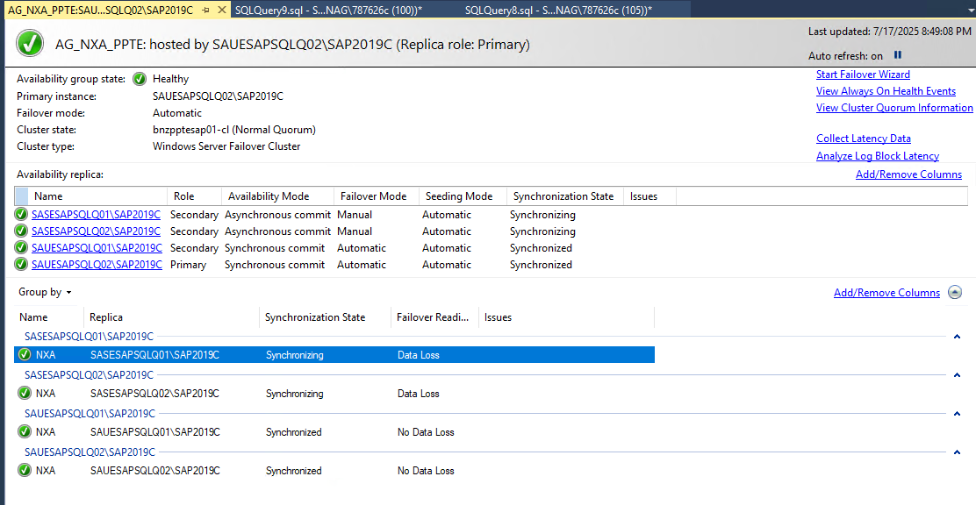

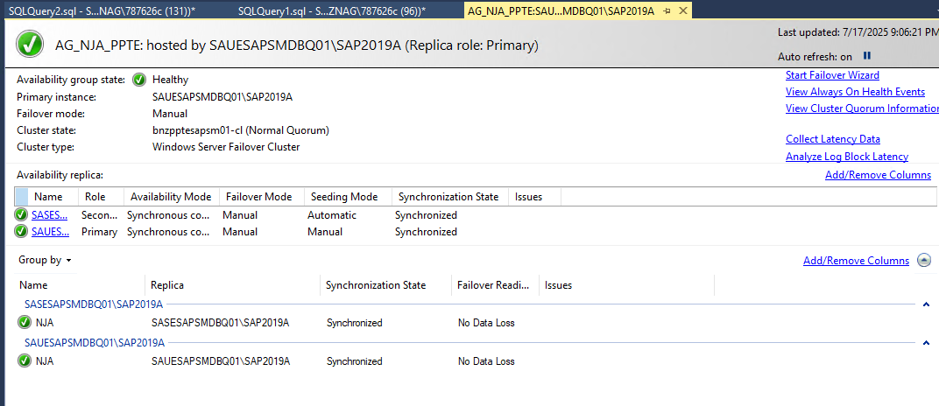

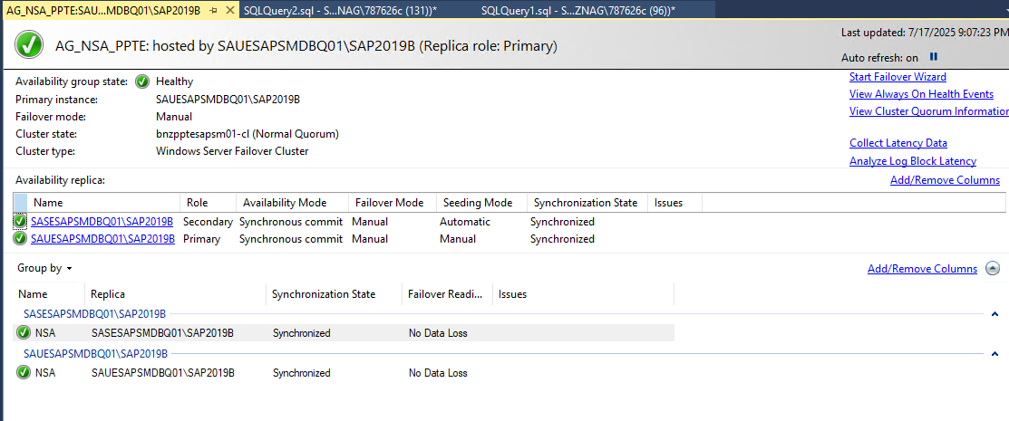

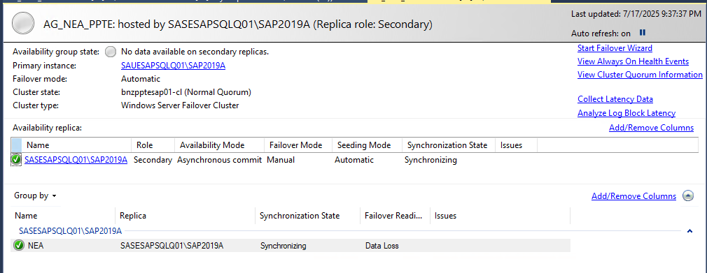

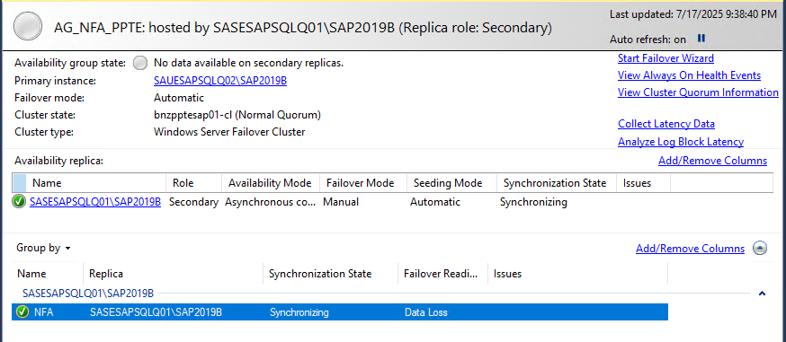

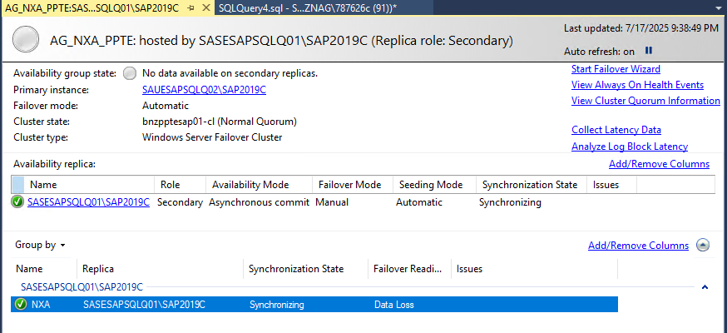

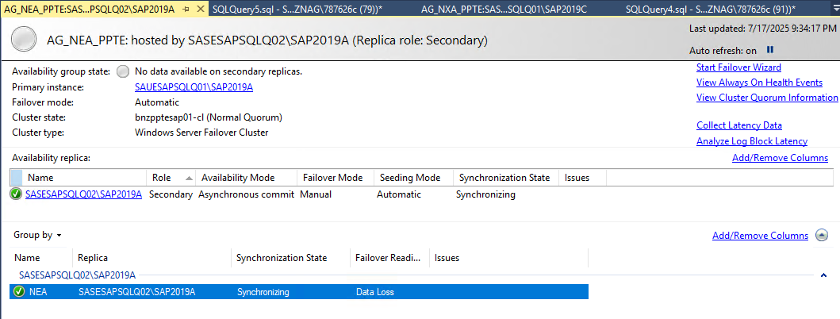

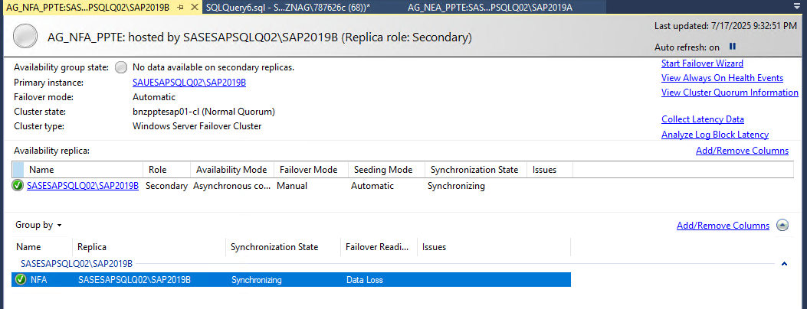

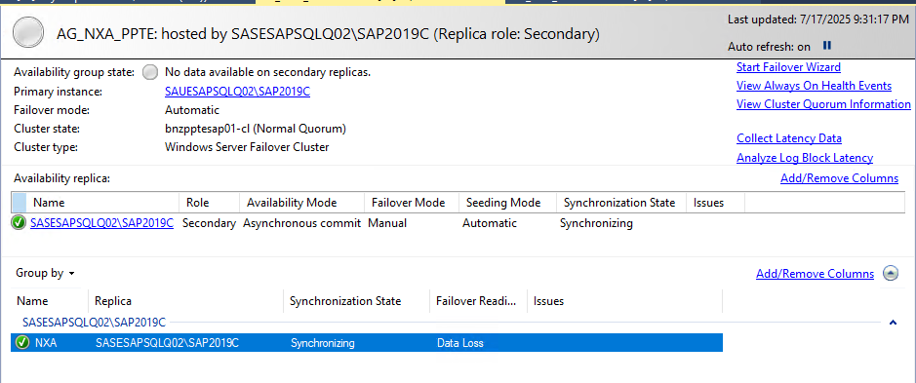

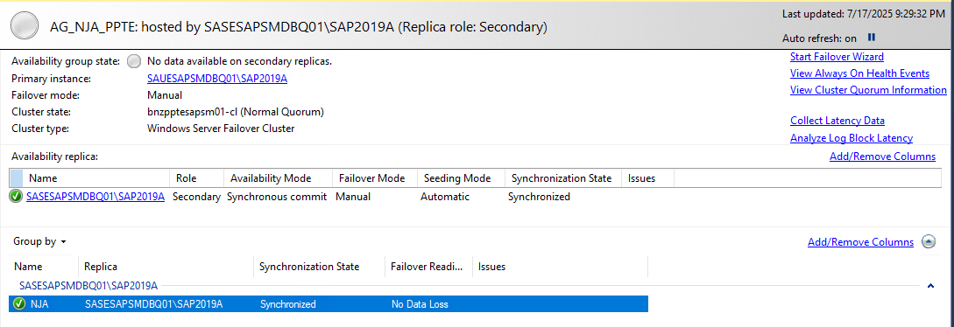

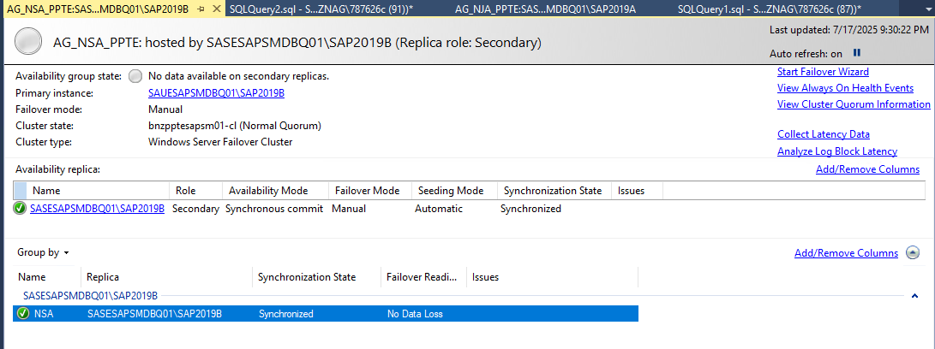

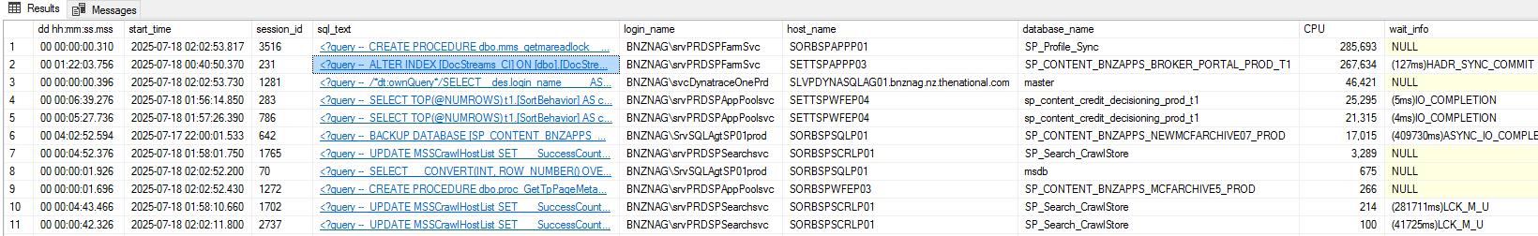

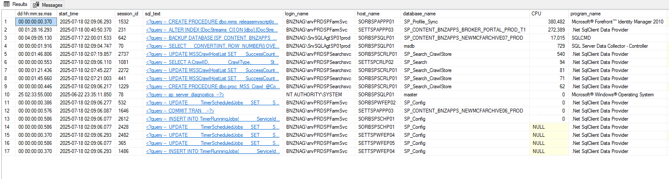

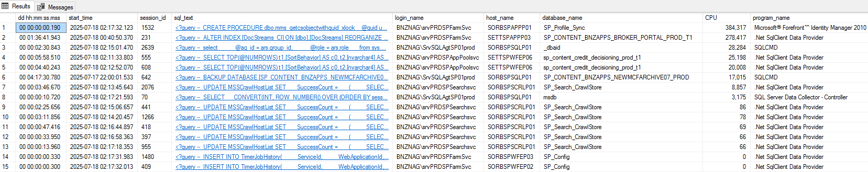

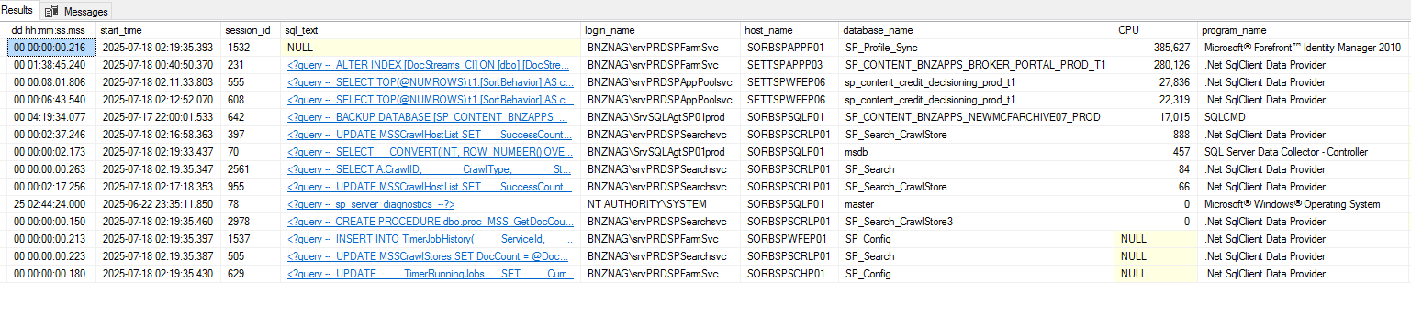

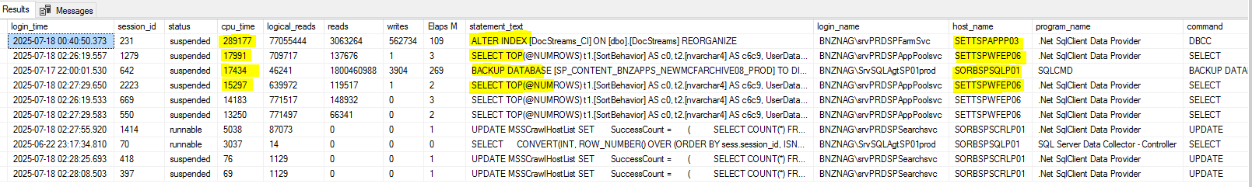

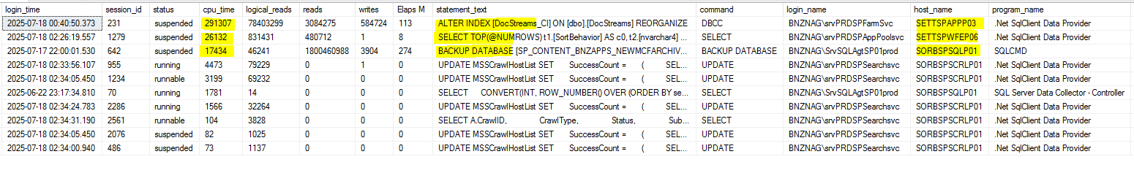

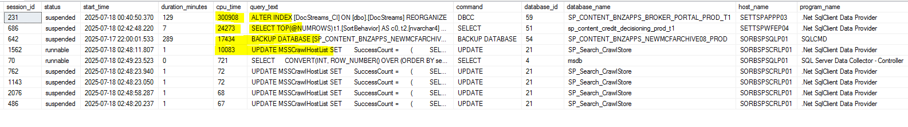

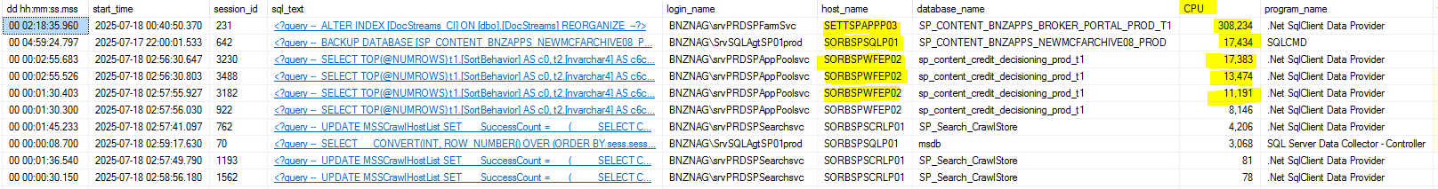

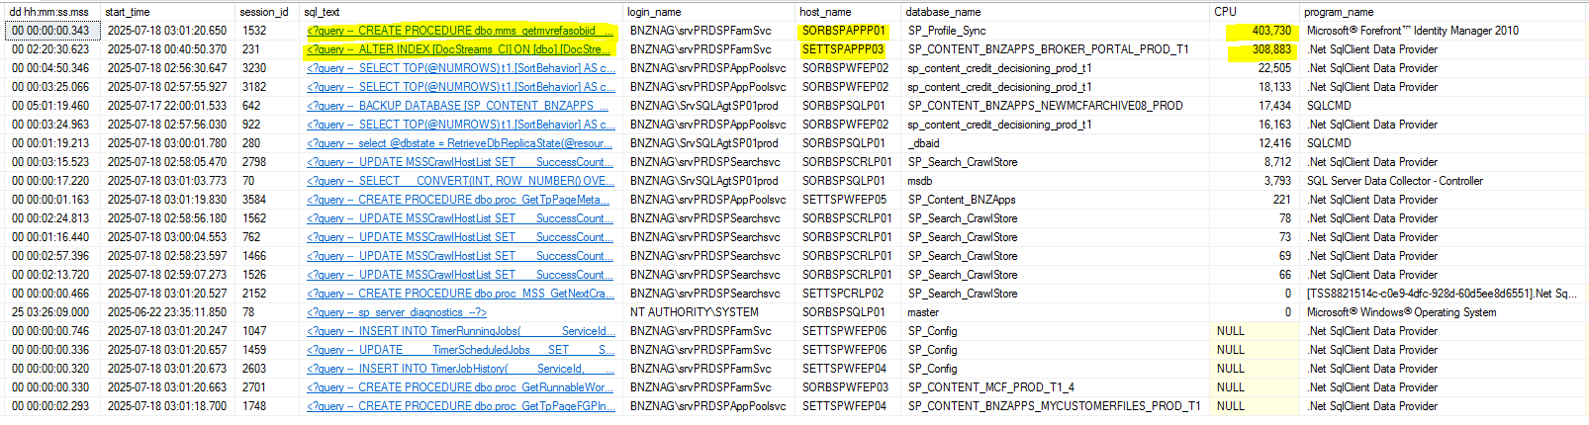

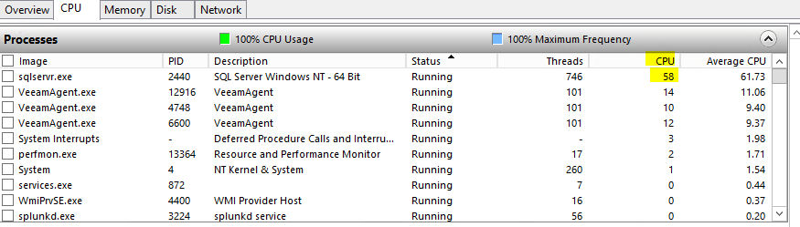

**18-07-2025 11:10 PM**

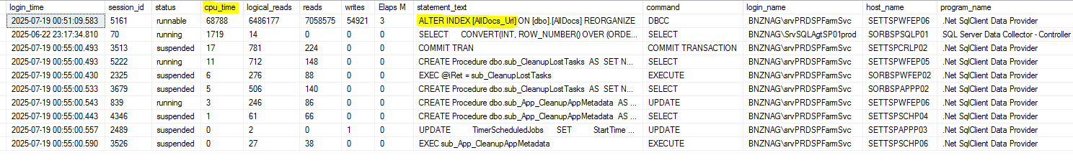



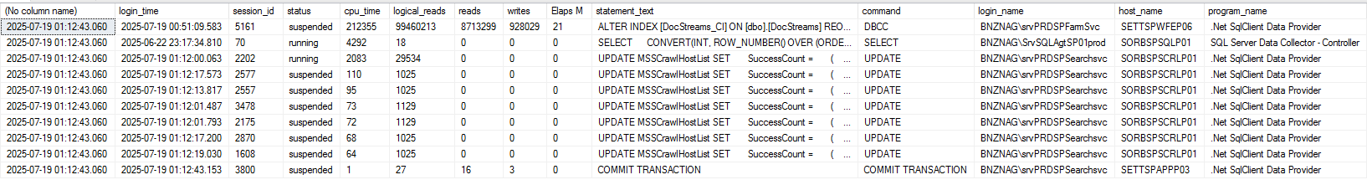

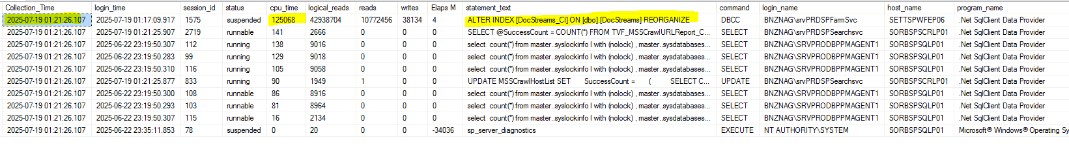

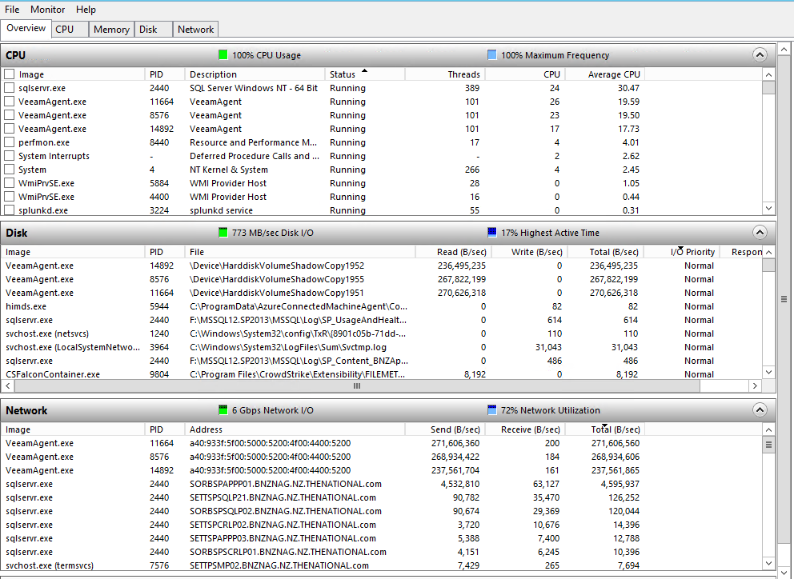

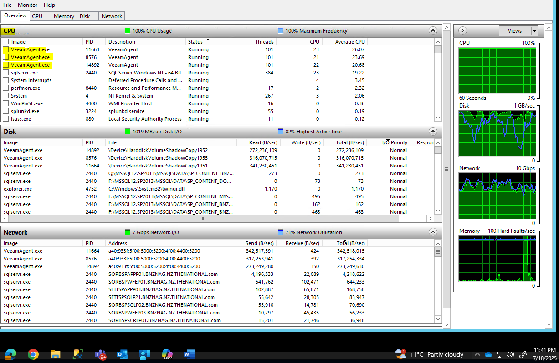

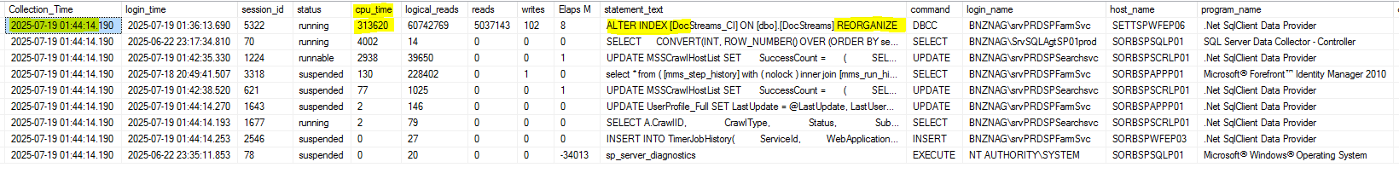

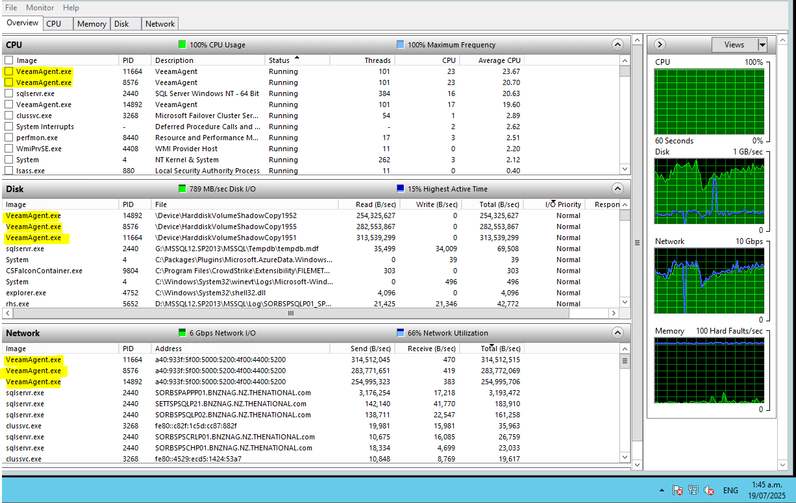

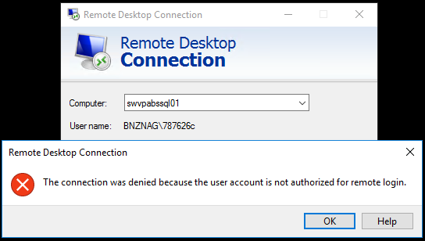

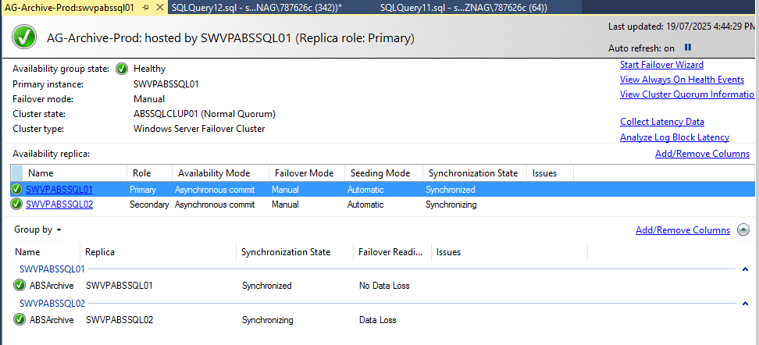



CHG000802591 – 19/07/2025 16:30 PM

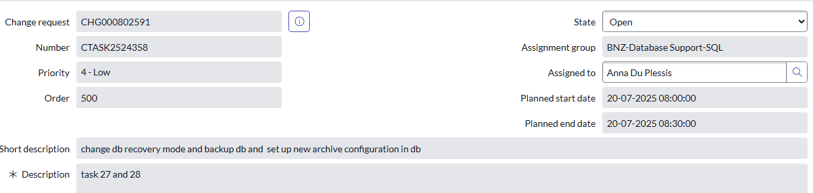

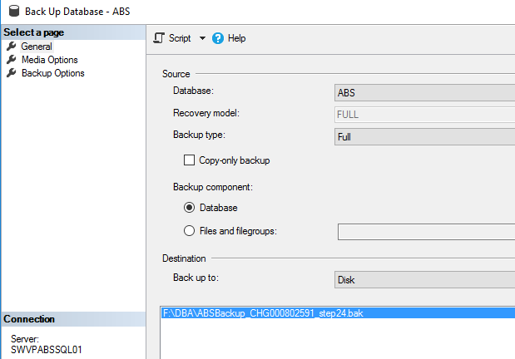

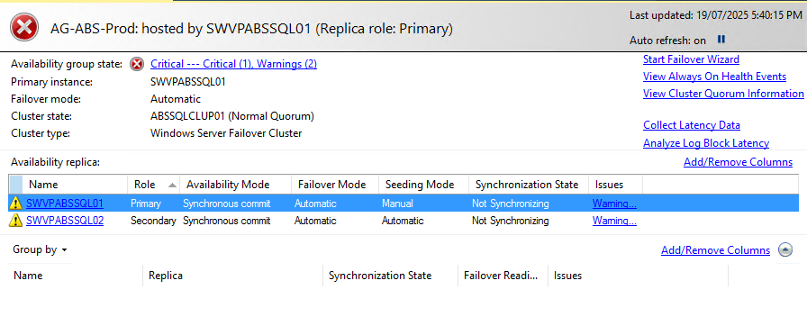

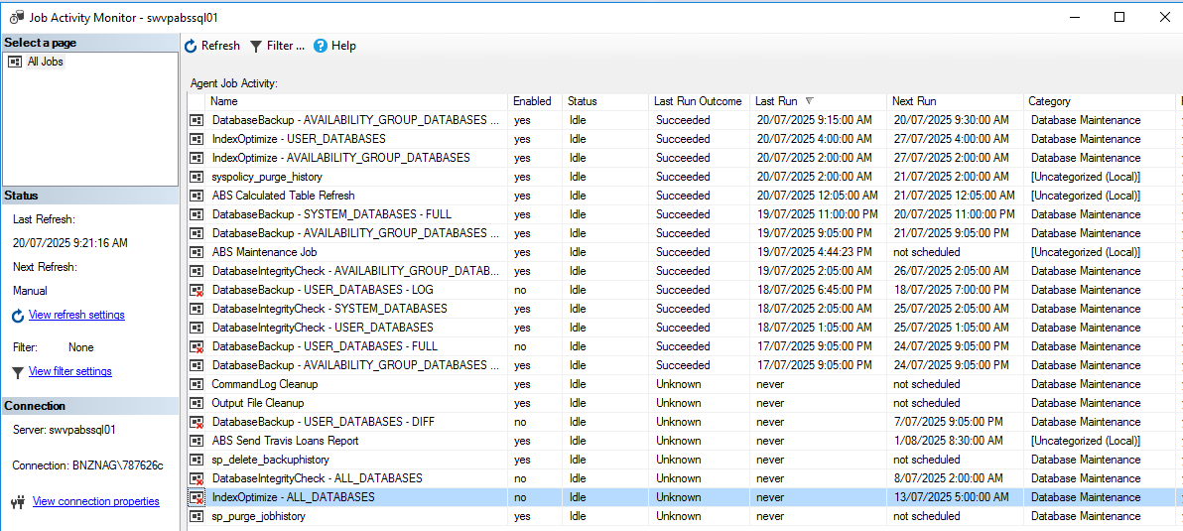

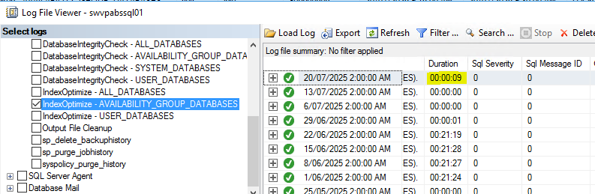

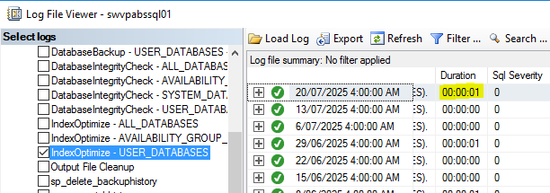

SAKLDMSQLP05\MSSQL2014 - OLD - ADM - Weekly Merchant Report

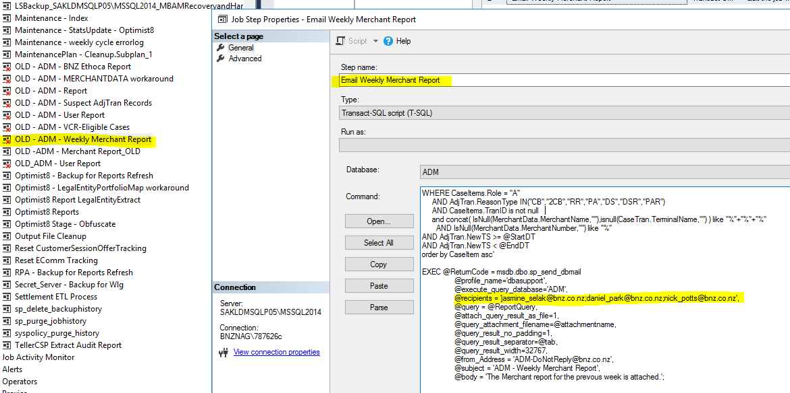

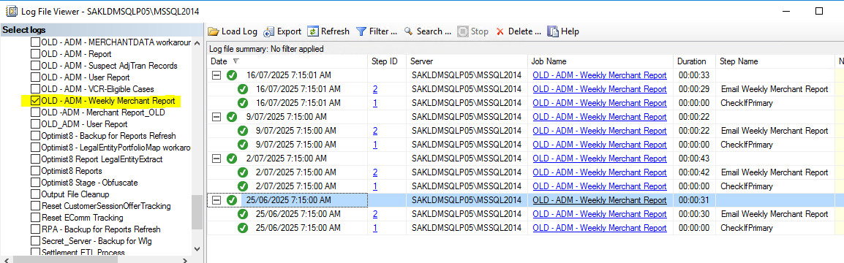

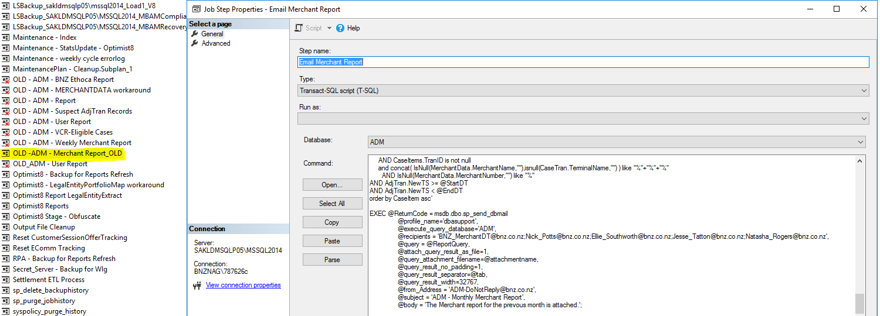

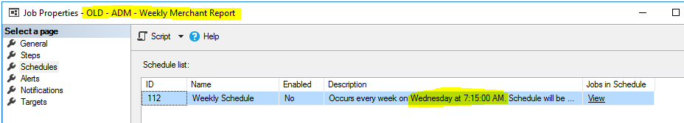

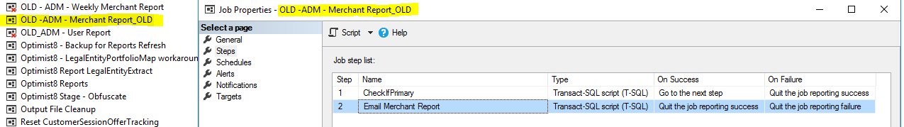

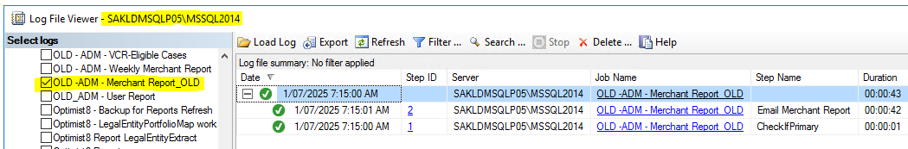

1. **2-8-2025 -** [**DASD-2381**](https://jira.nz.thenational.com/browse/DASD-2381)

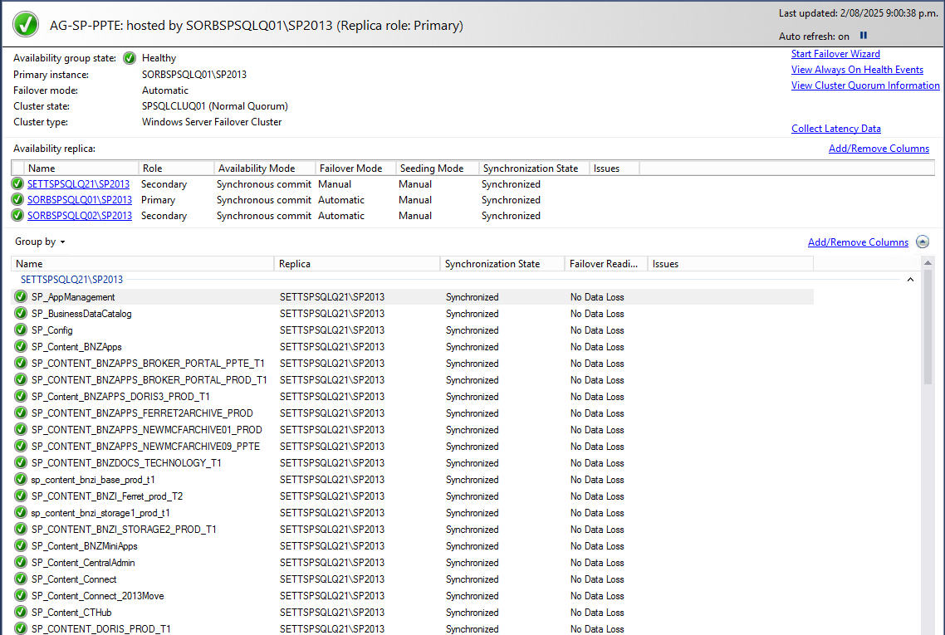

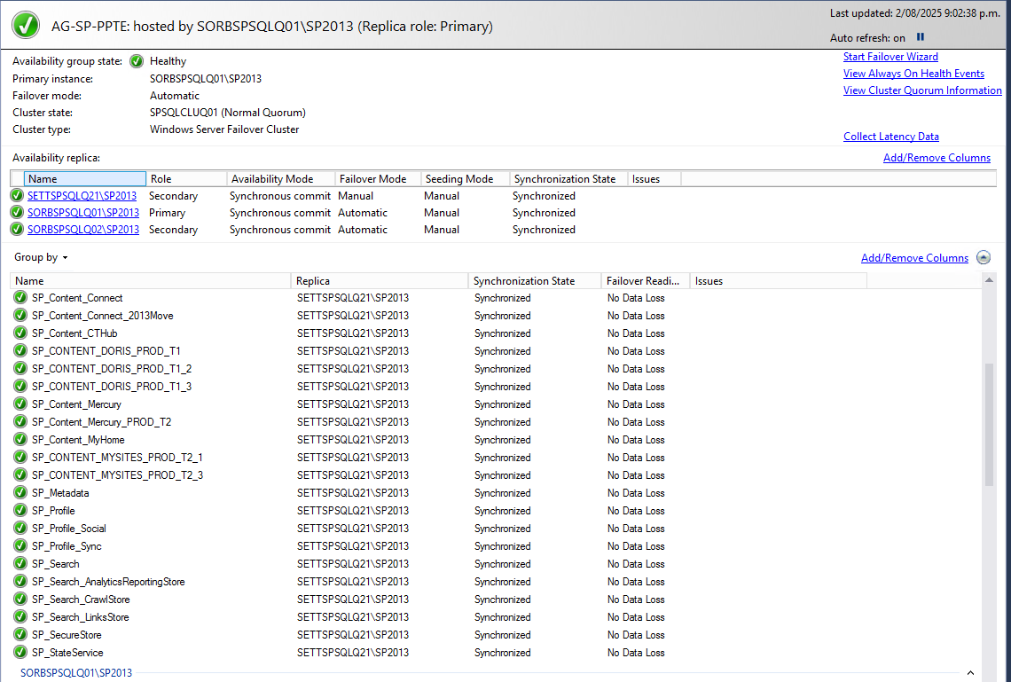

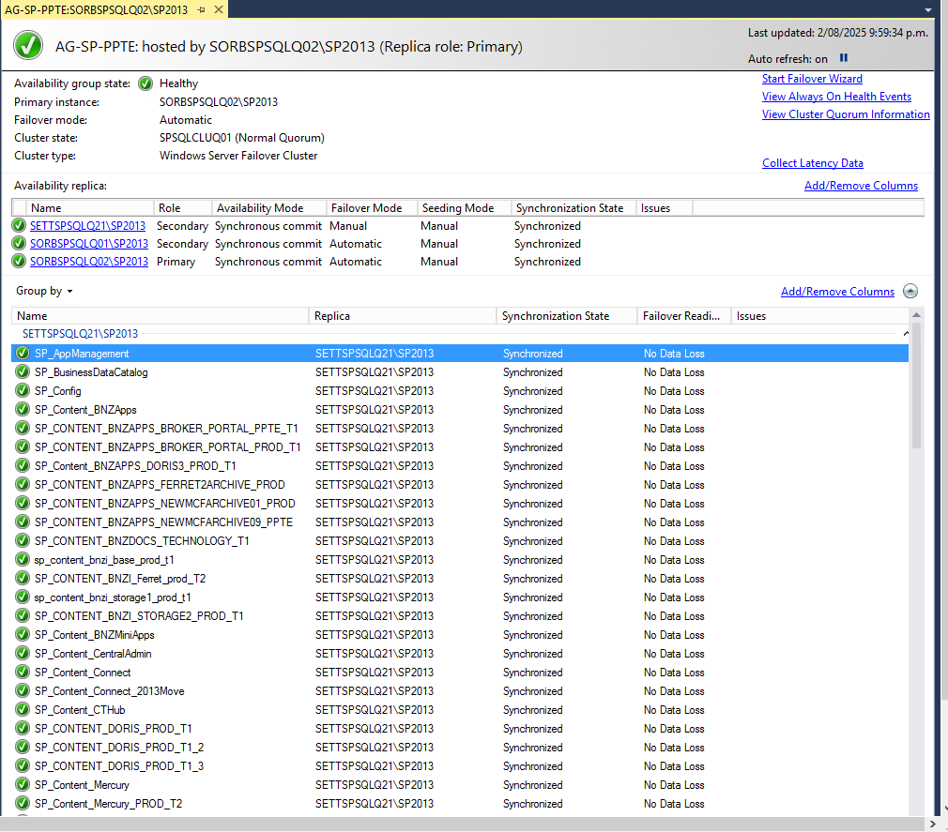

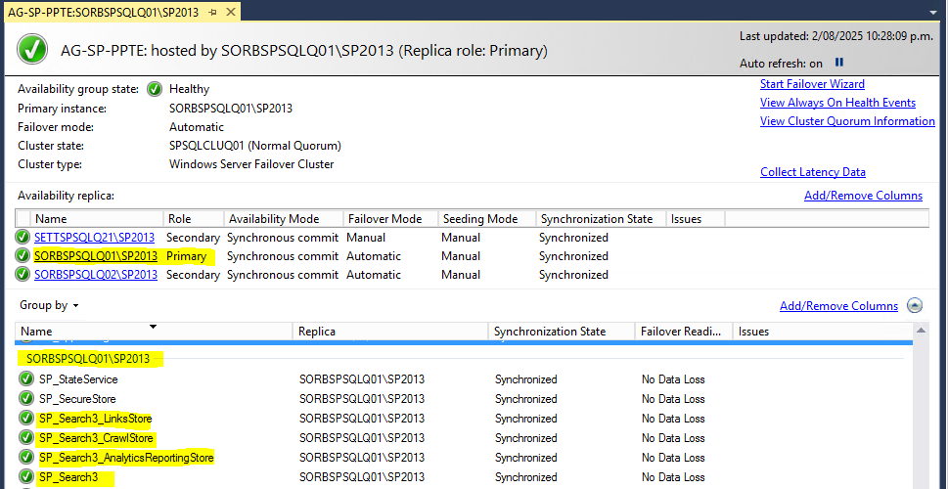

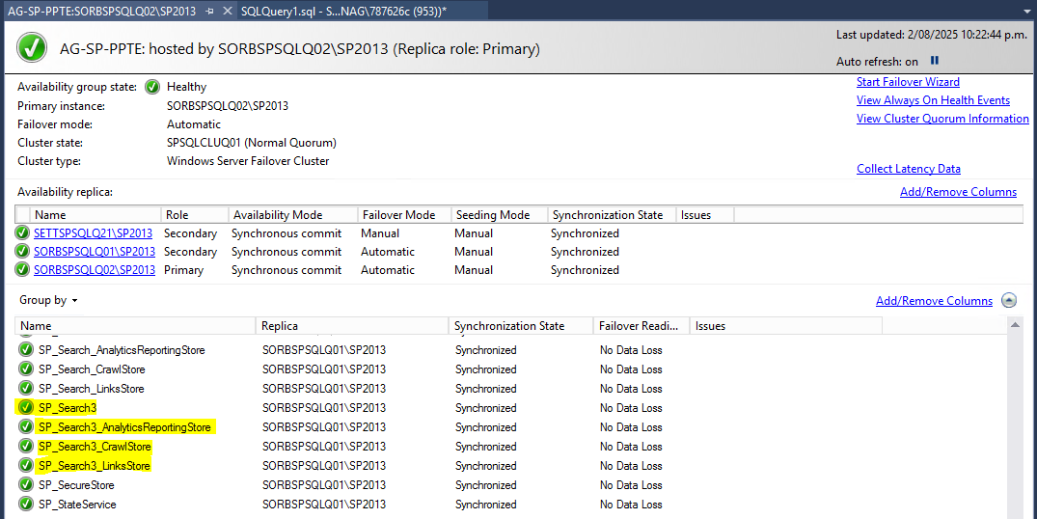

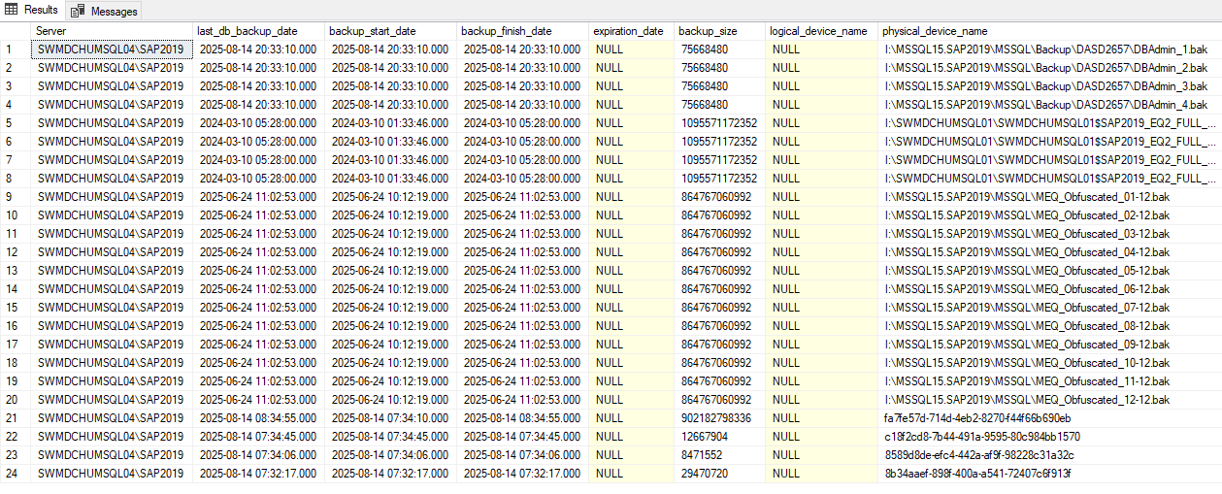

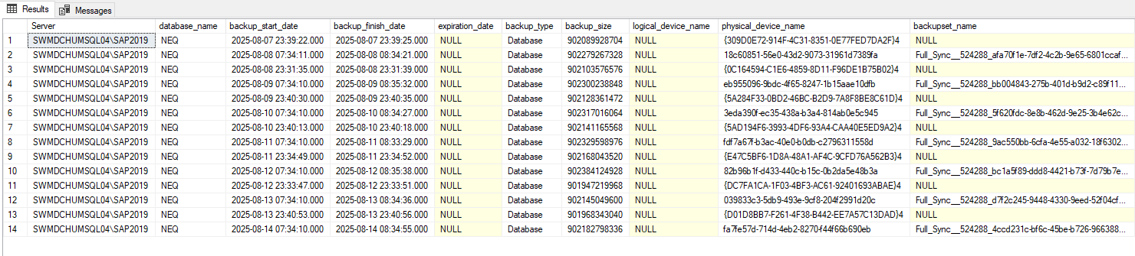

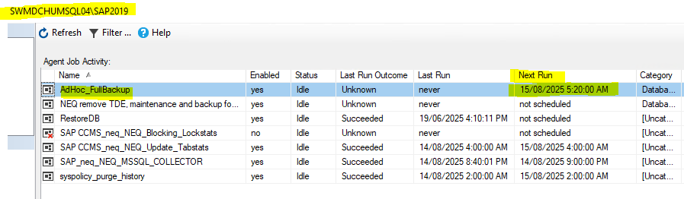

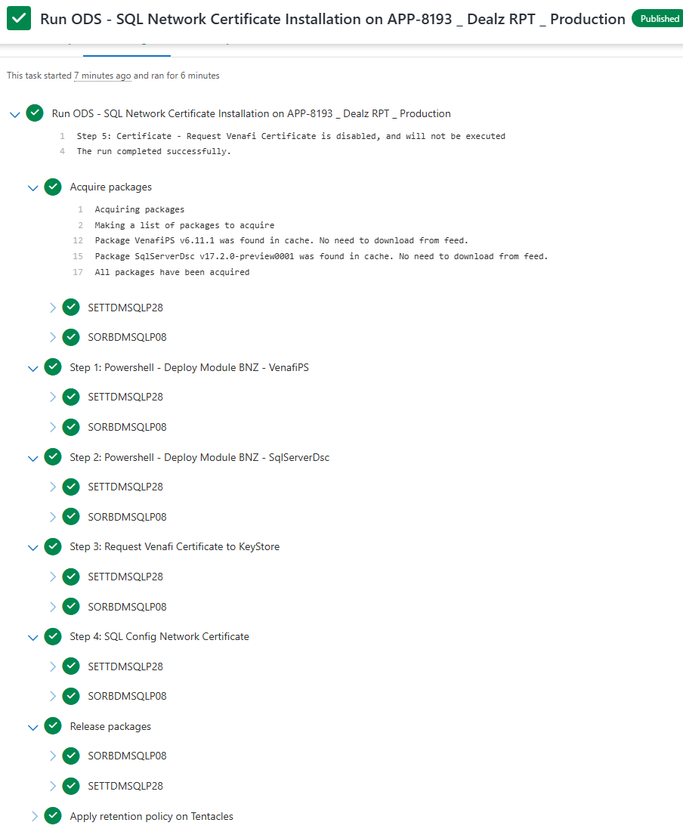

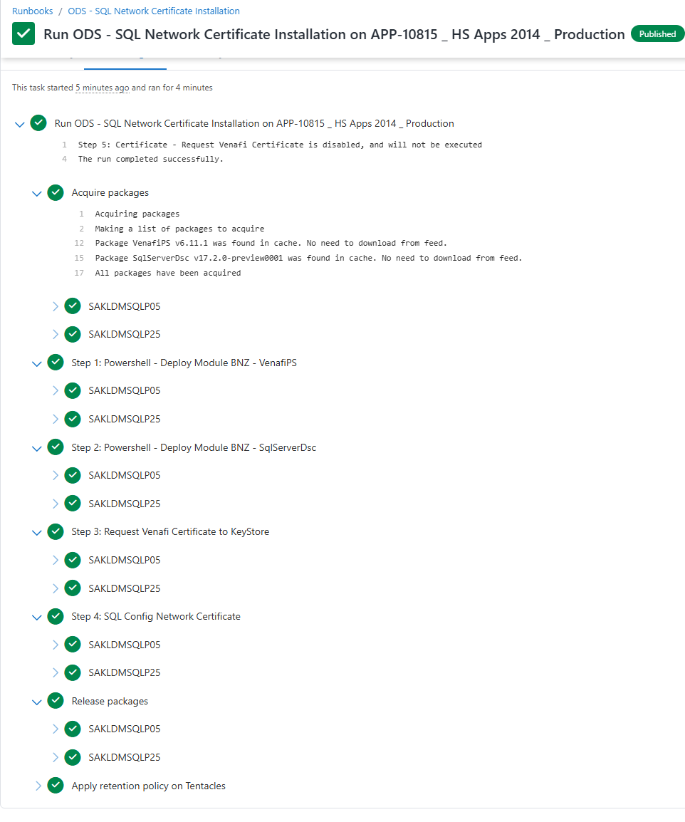

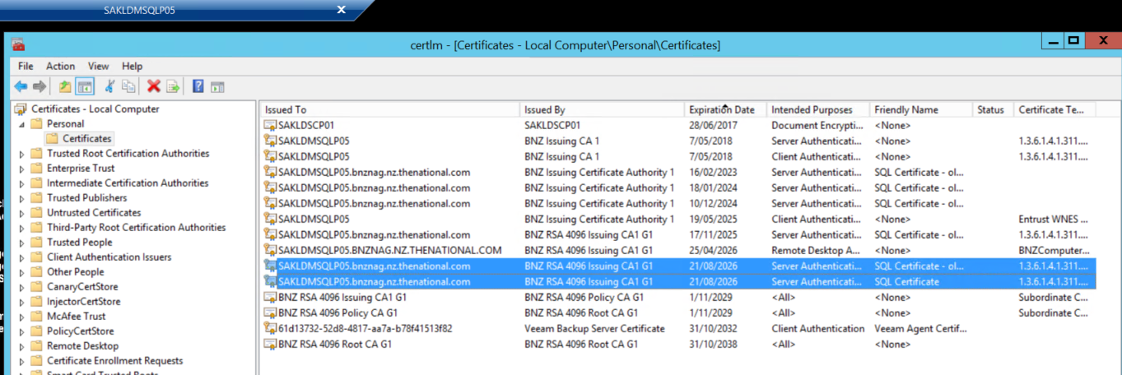

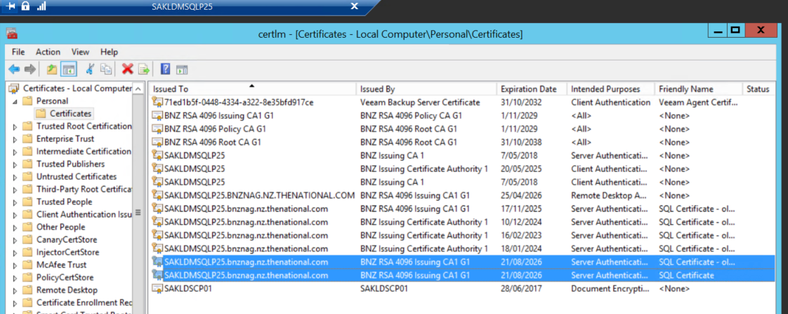

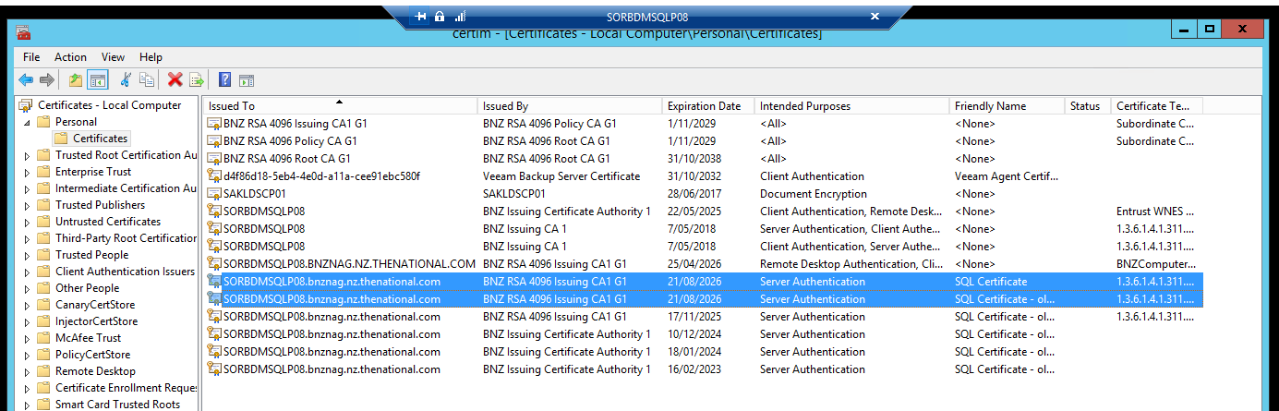

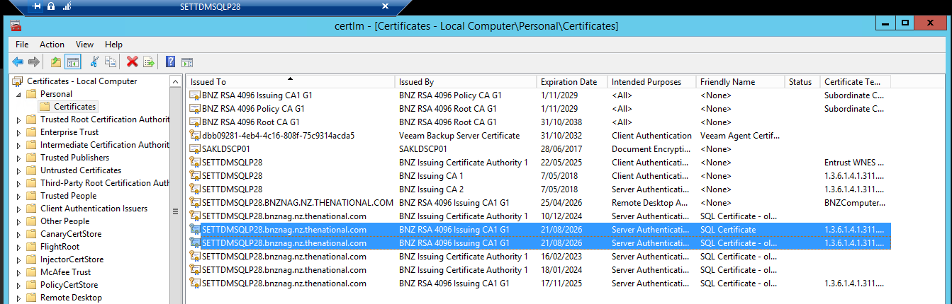

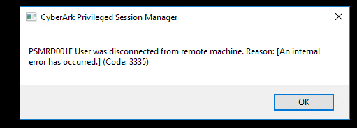

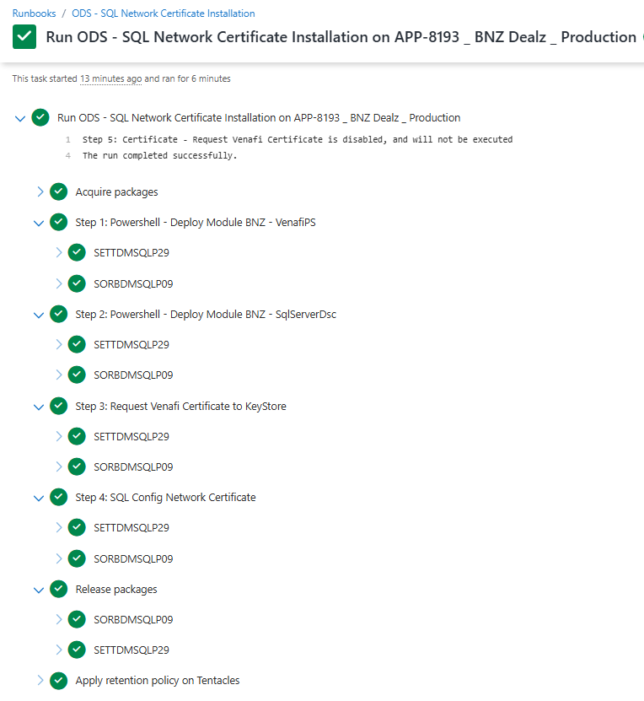

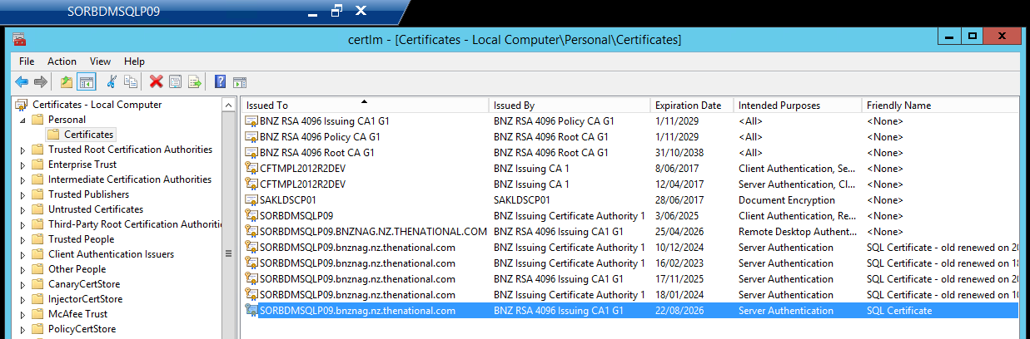

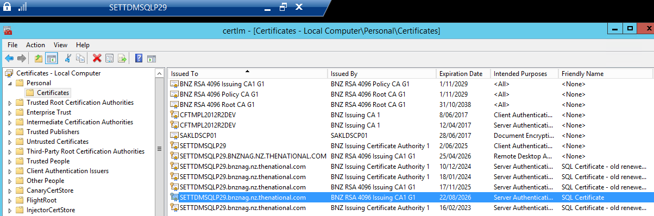

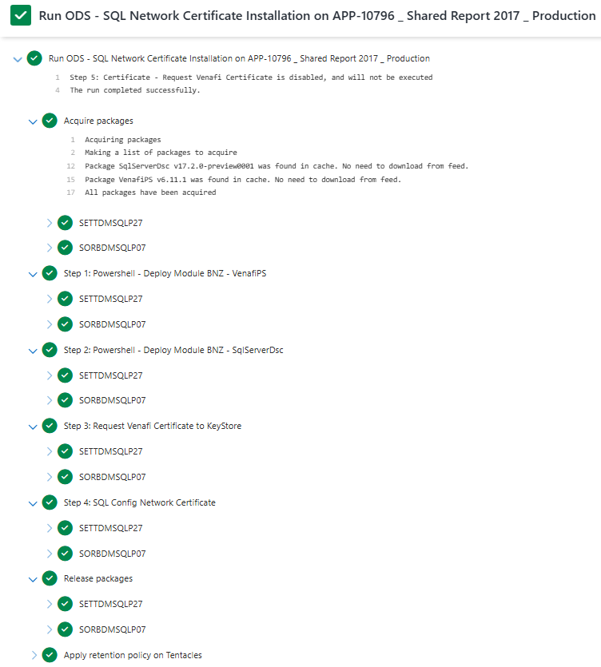

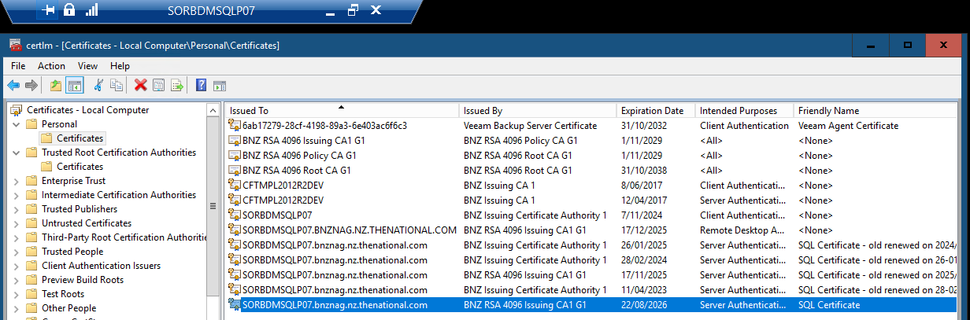

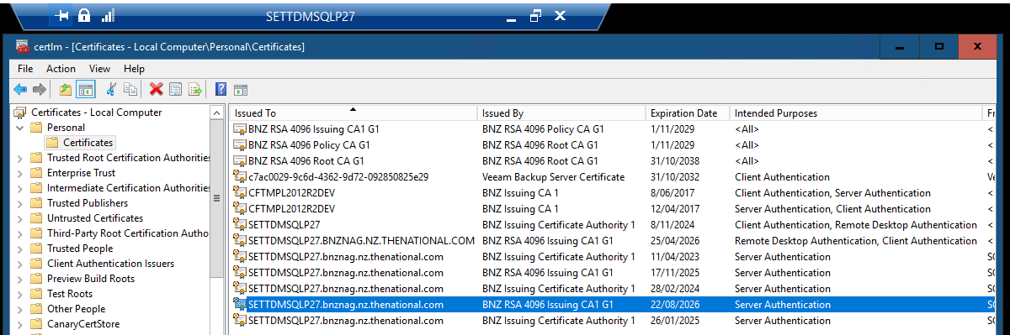

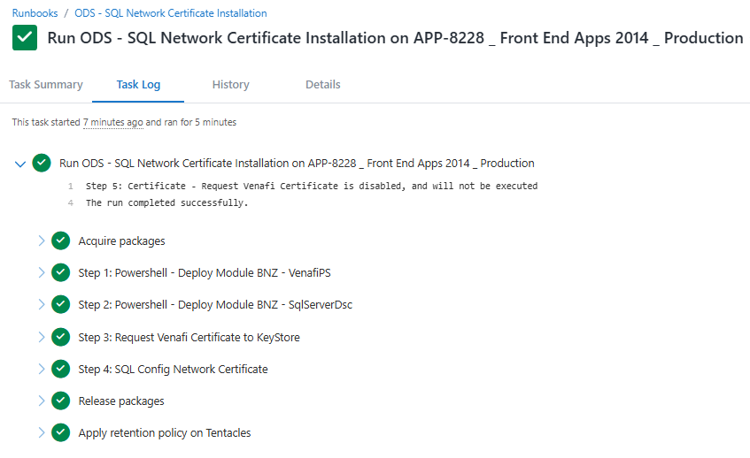

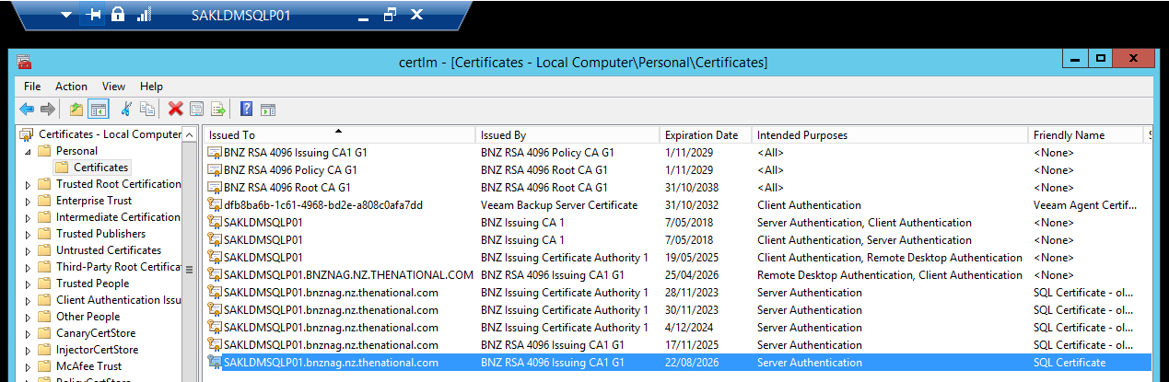

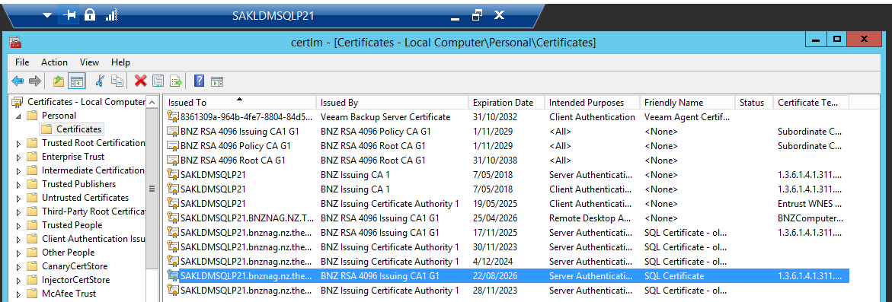

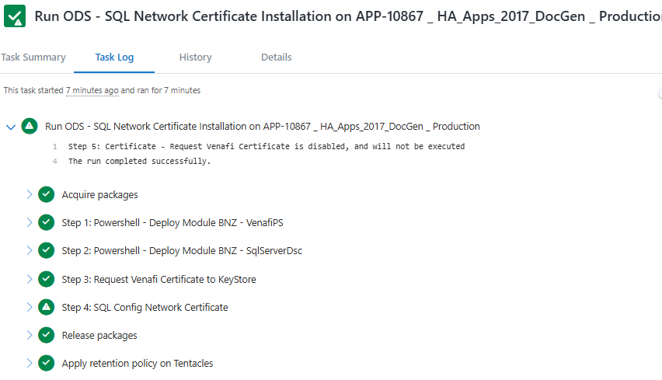

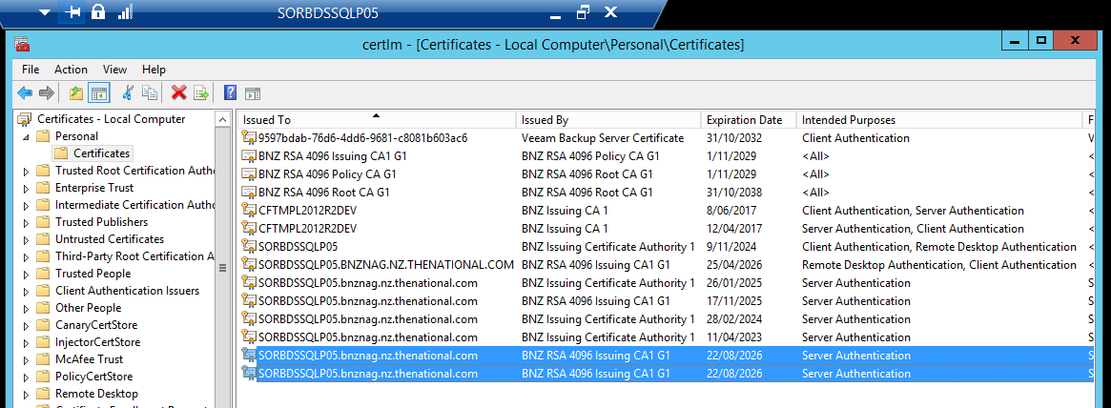

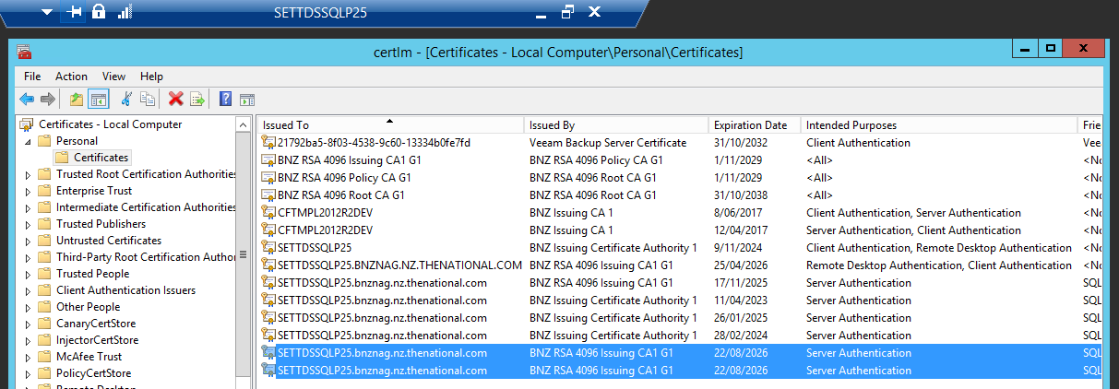

1. [nz.co](http://nz.co/).bnz.apex.APEXApprove - SQL Exception.   Aborting Run.  SQLErrorCode: 0 SQLState: 08S0:

***Meaning*:** *SQLState communication link failure (network disconnect, timeout or connection reset)*

**Possible causes:**

* Network connectivity issue between app and SQL Server.
* Firewall/timeout settings dropped session.
* SQL Server restarted or become unresponsive.

**Resolution:**

* Check SQL Server and network logs for disconnection.
* Verify connectivity by ping, Test-NetConnection or JDBC driver test
* Review application logs.
* Increase JDBC connection timeout or configure connection retires in app.

1. [nz.co](http://nz.co/).bnz.apex.APEXApplication - Caught SQLException in placeInQueue. Code is: 2627

***Meaning:*** *SQL Error: 2627 – violation of Primary Key constraint. cannot insert duplicate key in object.*

**Possible causes:**

* Application tried to insert duplicate values into a column that must be unique (primary key or unique index)

**Resolution:**

* Add proper checks in application logic before inserting data.

1. [nz.co](http://nz.co/).bnz.apex.APEXFileCopy - SQL Exception.   Aborting Run.  SQLErrorCode: 0 SQLState: 08S01 (Connection reset by peer: socket write error)

***Meaning:***SQLState 08S01 “Connection reset by peer” = SQL Server termination the TCP connection unexpectedly

**Possible causes:**

* SQL server services restarted, or connection forcibly closed.
* Idle connections being killed by firewall, proxy or load balancer.
* Network hiccups, packet drops.

**Resolution:**

* Check SQL Server logs for restarts.
* Configure JDBC connection poll with keep-alive or shorter timeout + retry Verify connectivity by ping, Test-NetConnection or JDBC driver test
* Review application logs.
* Apply latest JDBC driver (older sometimes cause socket issues).

1. [nz.co](http://nz.co/).bnz.common.util.DatabaseUtils - Cannot create Connection

***Meaning:*** *Application failed to establish a DB connection (root issue: 08S01 communication failure or SQL Server unavailable.*

**Possible causes:**

* All above issues (firewall, Network, SQL server not reachable)
* Connection pool exhaustion.

**Resolution:**

* Check port 1433 reachable.
* Monitor connection pool usage in the application.
* Increase pool size or fix code leaks that don’t close connections.
* 08S01 errors (communication failure/ connection reset) – Check network stability, firewall rules, SQL Server uptime, and JDBC driver version.
* Error 2627 (duplicate key) – Fix application logic or database design to handle duplicates properly.
* Connection creation errors – Check SQL Server availability, connection pool exhaustion, or incorrect JDBC settings.

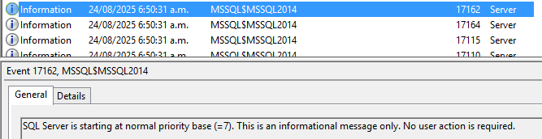

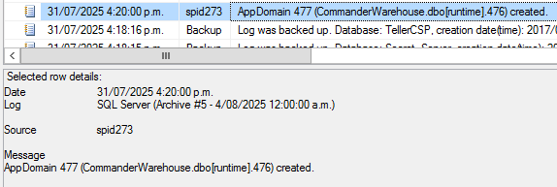

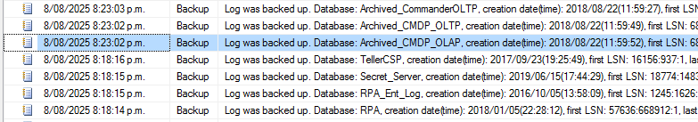

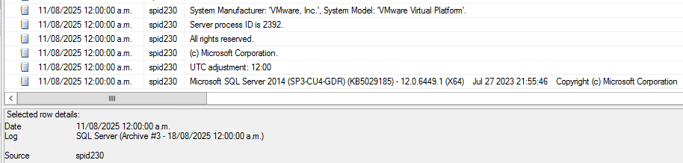

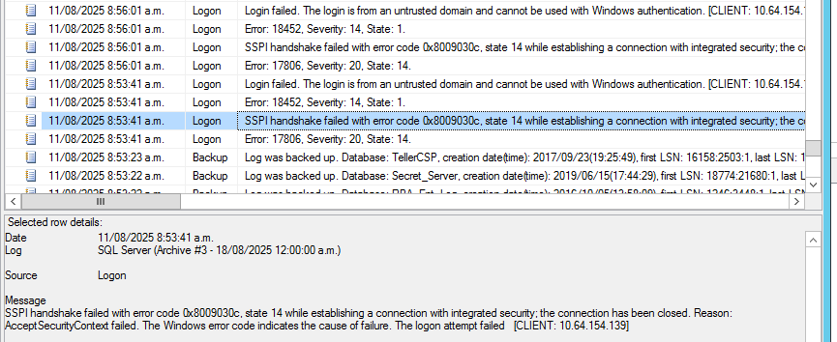

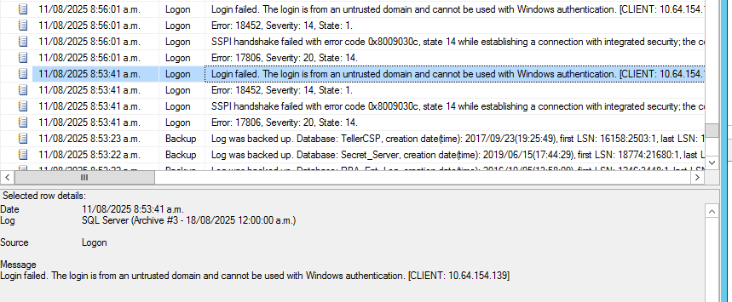

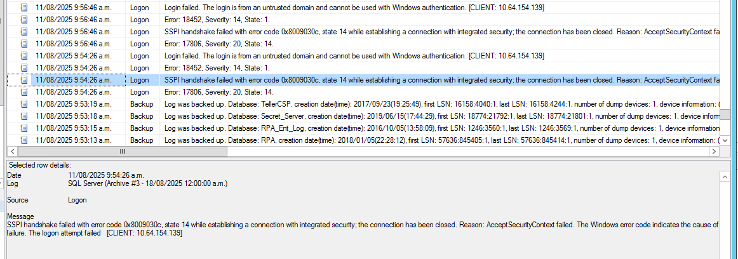

Message

Error: 17806, Severity: 20, State: 14.

Date 11/08/2025 9:54:26 a.m.

Log SQL Server (Archive #3 - 18/08/2025 12:00:00 a.m.)

Source Logon

Message

SSPI handshake failed with error code 0x8009030c, state 14 while establishing a connection with integrated security; the connection has been closed. Reason: AcceptSecurityContext failed. The Windows error code indicates the cause of failure. The logon attempt failed [CLIENT: 10.64.154.139]

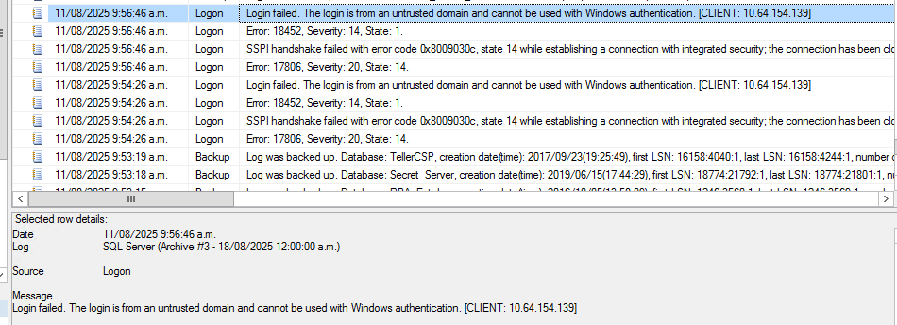

Message

Error: 18452, Severity: 14, State: 1.

Date 11/08/2025 9:54:26 a.m.

Log SQL Server (Archive #3 - 18/08/2025 12:00:00 a.m.)

Source Logon

Message

Login failed. The login is from an untrusted domain and cannot be used with Windows authentication. [CLIENT: 10.64.154.139]

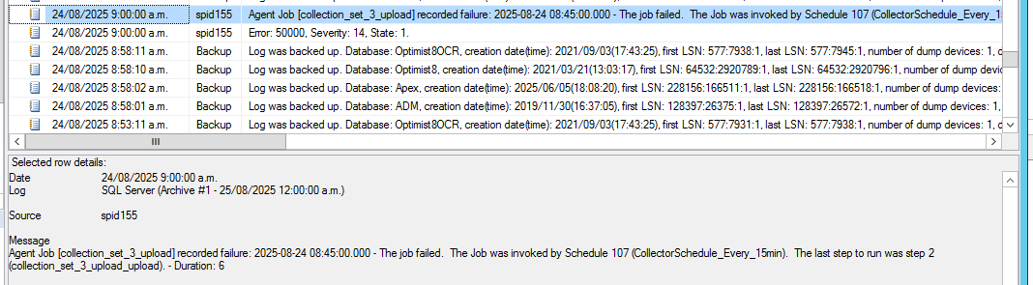

Message

Agent Job [collection_set_3_upload] recorded failure: 2025-08-24 08:45:00.000 - The job failed. The Job was invoked by Schedule 107 (CollectorSchedule_Every_15min). The last step to run was step 2 (collection_set_3_upload_upload). - Duration: 6

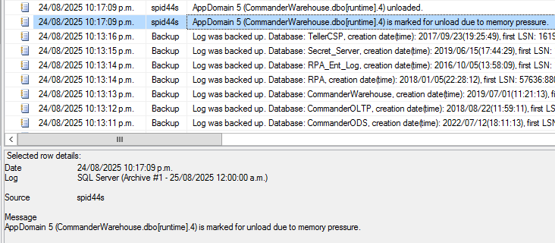

Message

AppDomain 5 (CommanderWarehouse.dbo[runtime].4) unloaded.

Message

AppDomain 5 (CommanderWarehouse.dbo[runtime].4) is marked for unload due to memory pressure.

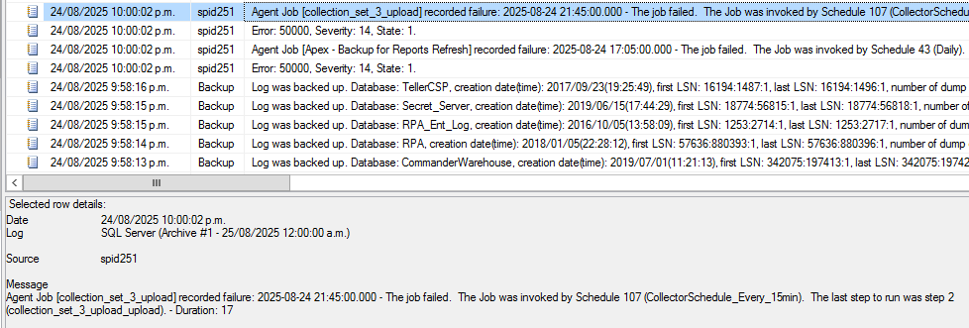

Message

Agent Job [collection_set_3_upload] recorded failure: 2025-08-24 21:45:00.000 - The job failed. The Job was invoked by Schedule 107 (CollectorSchedule_Every_15min). The last step to run was step 2 (collection_set_3_upload_upload). - Duration: 17

Message

Error: 50000, Severity: 14, State: 1.

Message

Agent Job [Apex - Backup for Reports Refresh] recorded failure: 2025-08-24 17:05:00.000 - The job failed. The Job was invoked by Schedule 43 (Daily). The last step to run was step 1 (Check If Primary). - Duration: 0

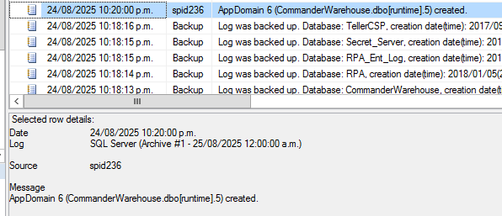

Message

AppDomain 6 (CommanderWarehouse.dbo[runtime].5) created.

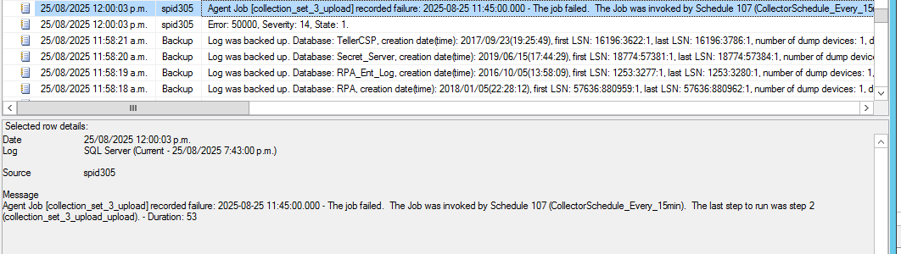

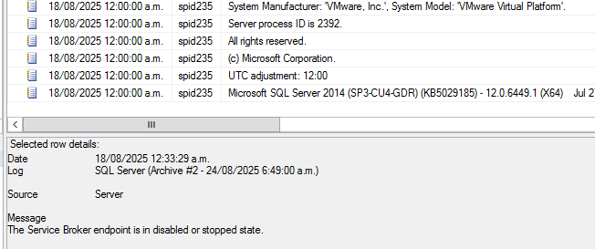

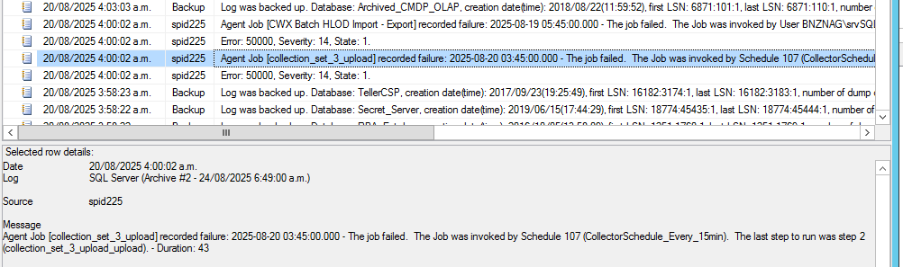

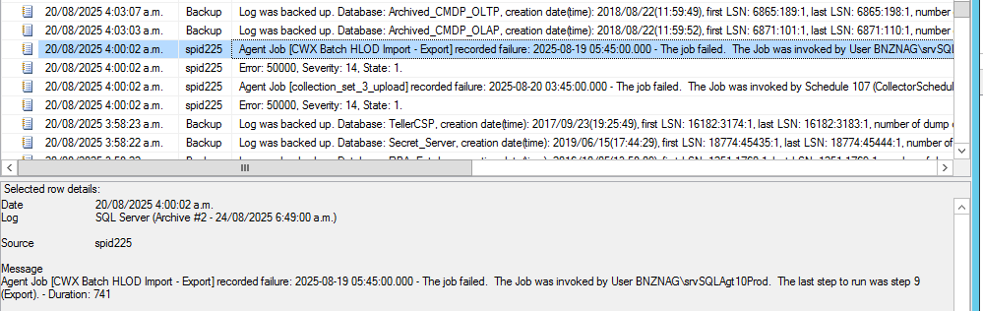

Message

Agent Job [CWX Batch HLOD Import - Export] recorded failure: 2025-08-19 05:45:00.000 - The job failed. The Job was invoked by User BNZNAG\srvSQLAgt10Prod. The last step to run was step 9 (Export). - Duration: 741

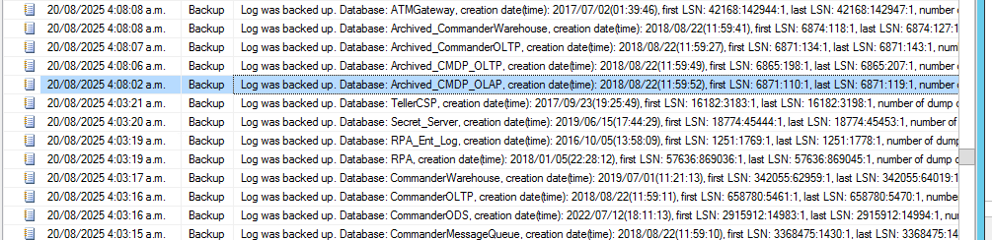

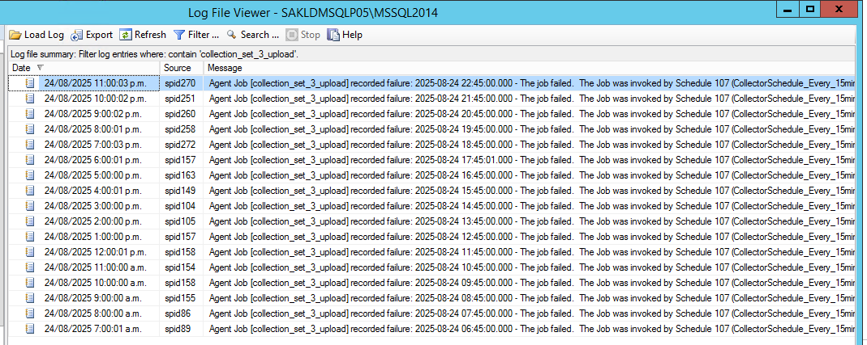

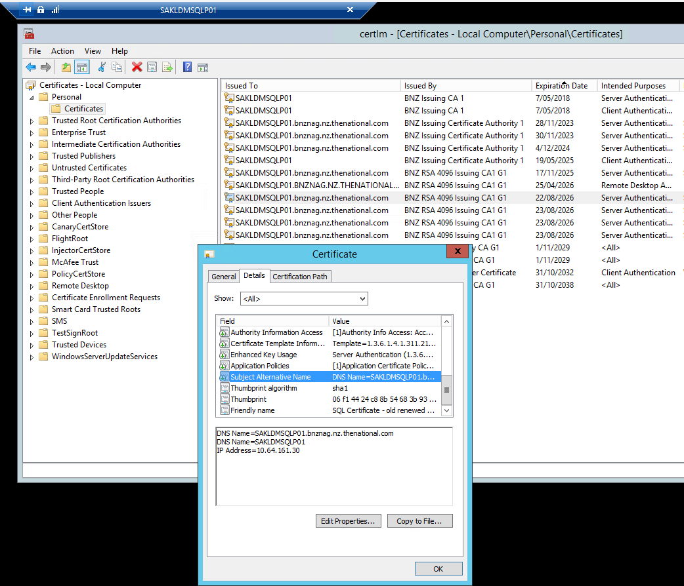

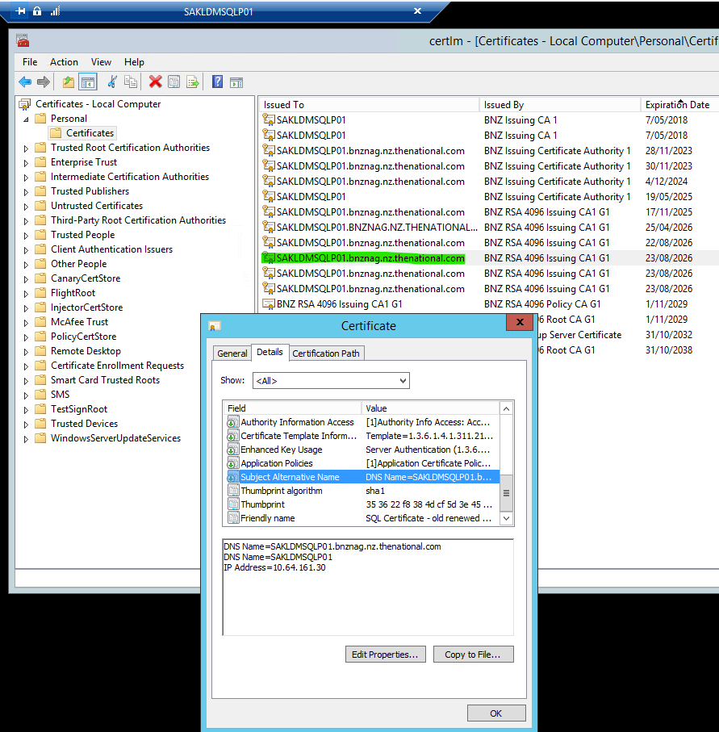

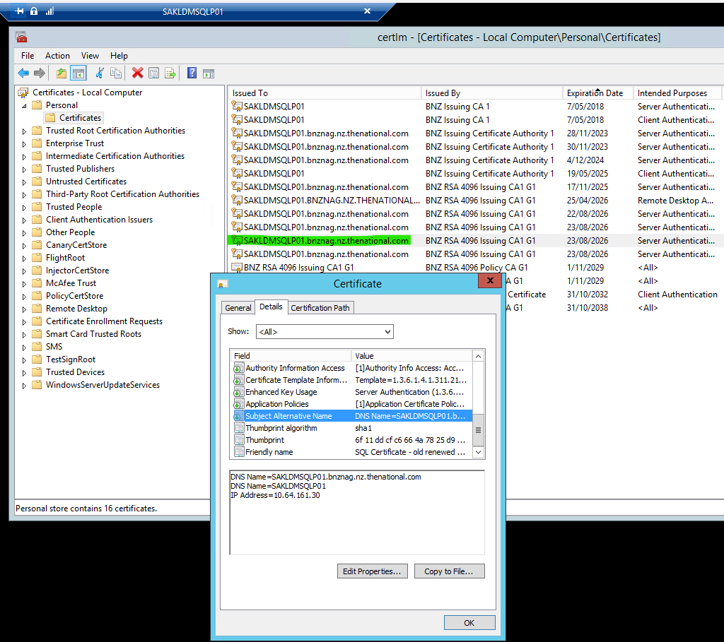

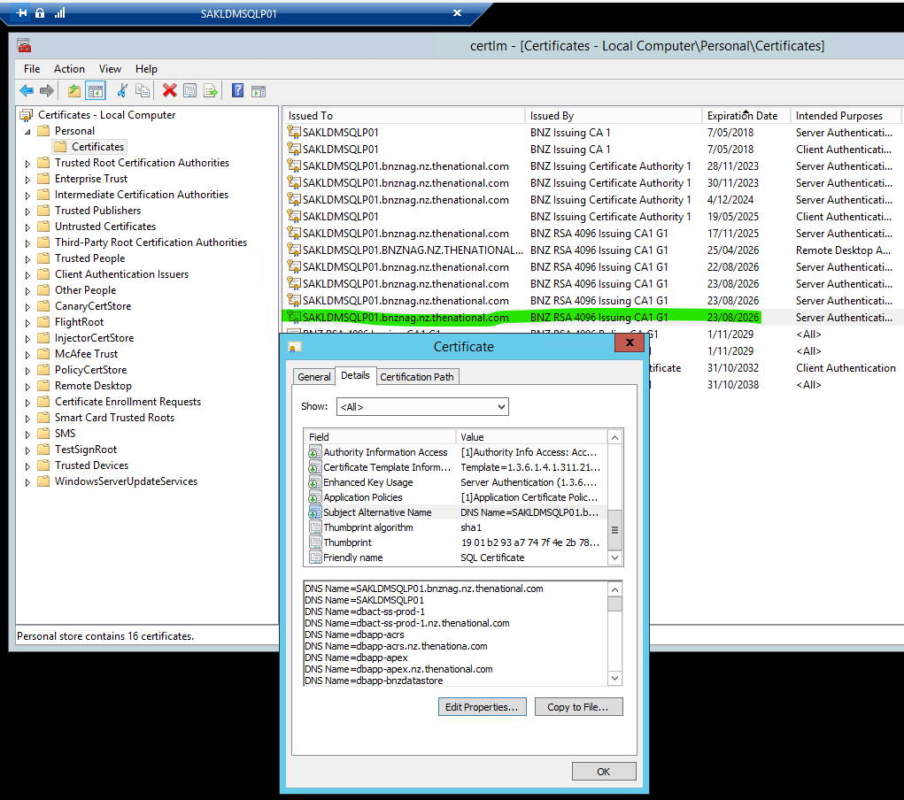

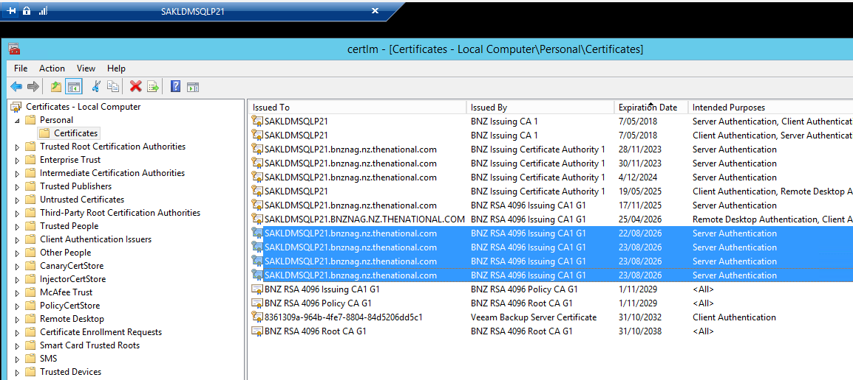

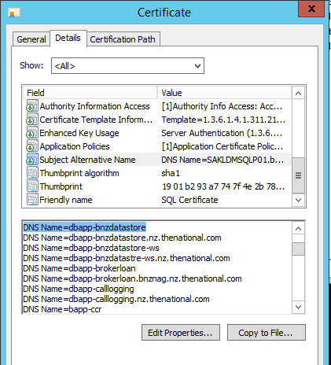

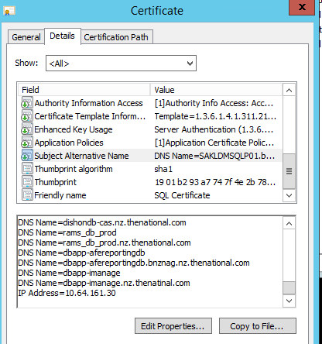

**Previous One to Tally the content Should be MATCH**

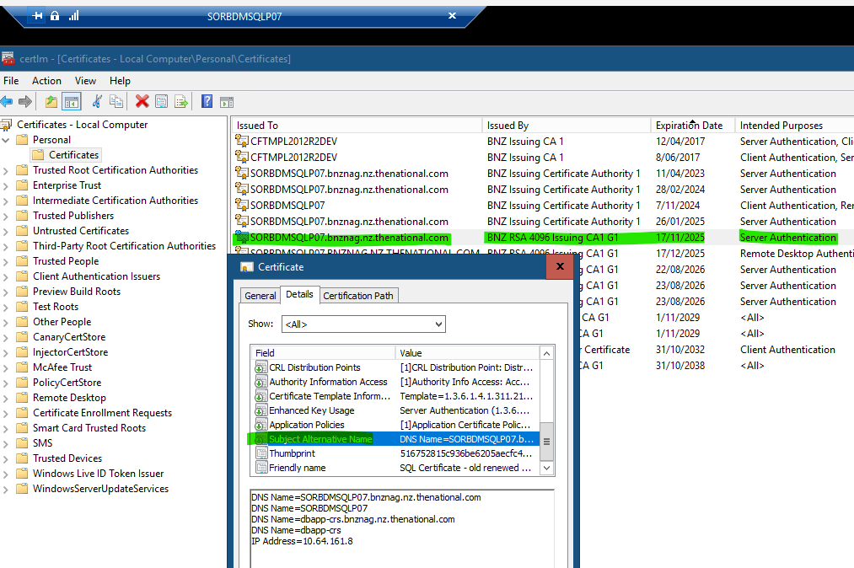

**Incorrect One**

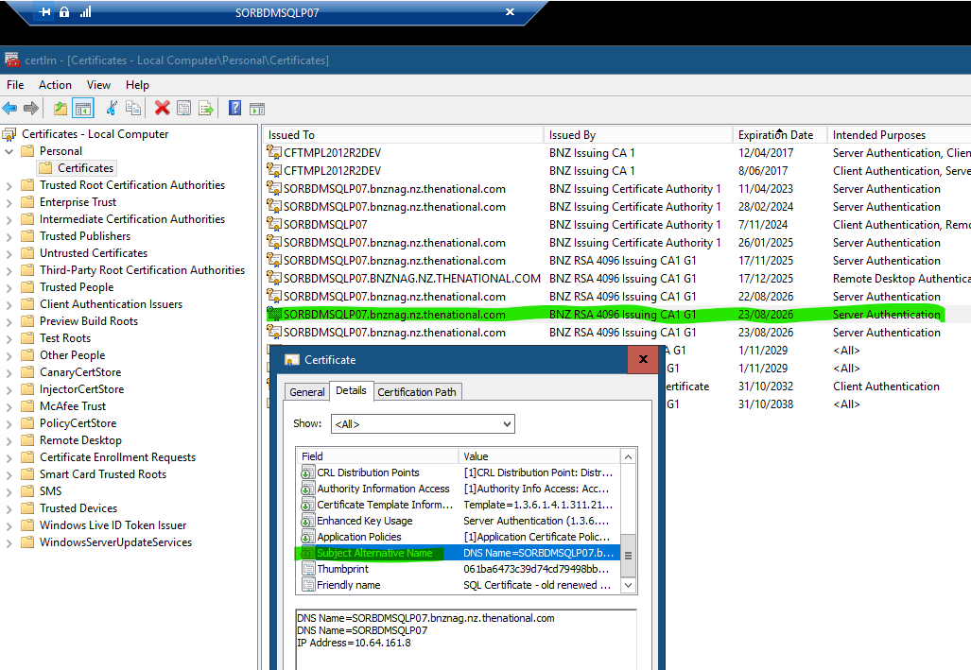

**Correct One Added on same day by adding content in Project Variables Section on**

[APP-10708 _ BNZ MSSQL Server _ Deployment and Operational Tasks - Project Variables - Octopus Deploy](https://octopus-os/app#/Spaces-2/projects/app-10708-bnz-mssql-server-deployment-and-operational-tasks/variables)

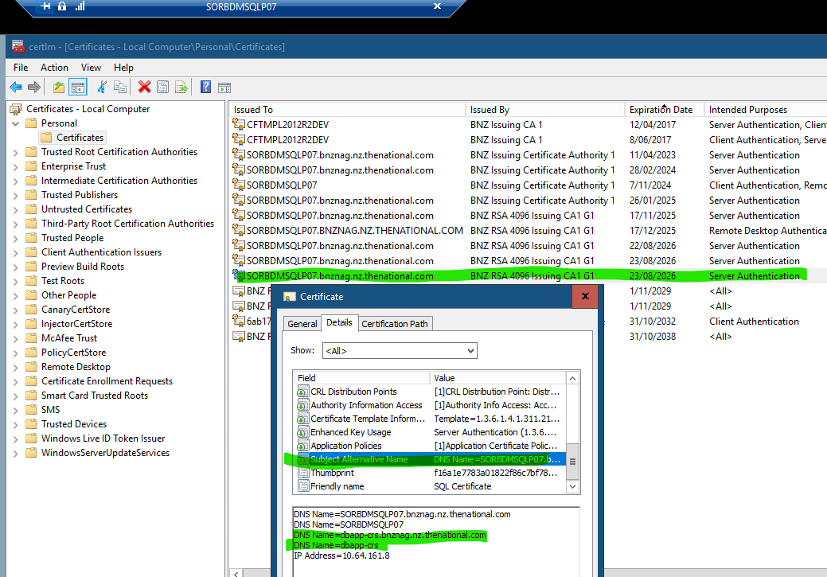

**Instructions from Anna**

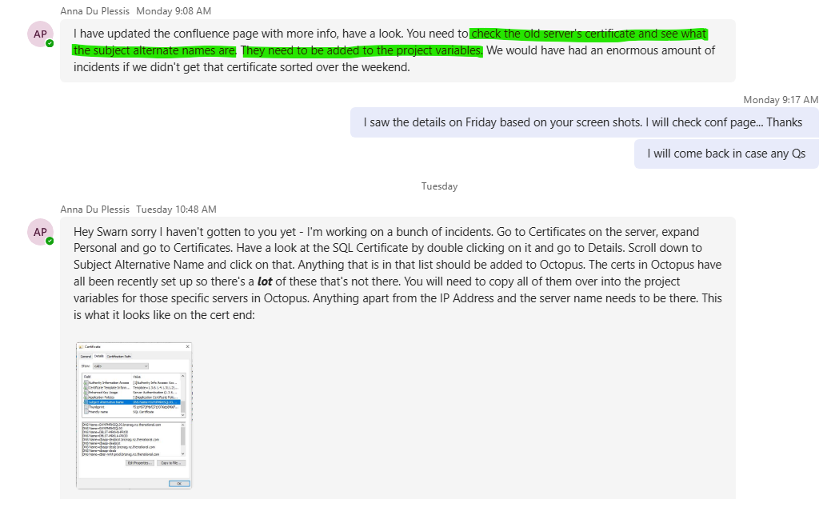

**https://jira.nz.thenational.com/browse/DASD-2794**

**SORBDMSQLP06.bnznag.nz.thenational.com Certificate Expiring in 90 Days**

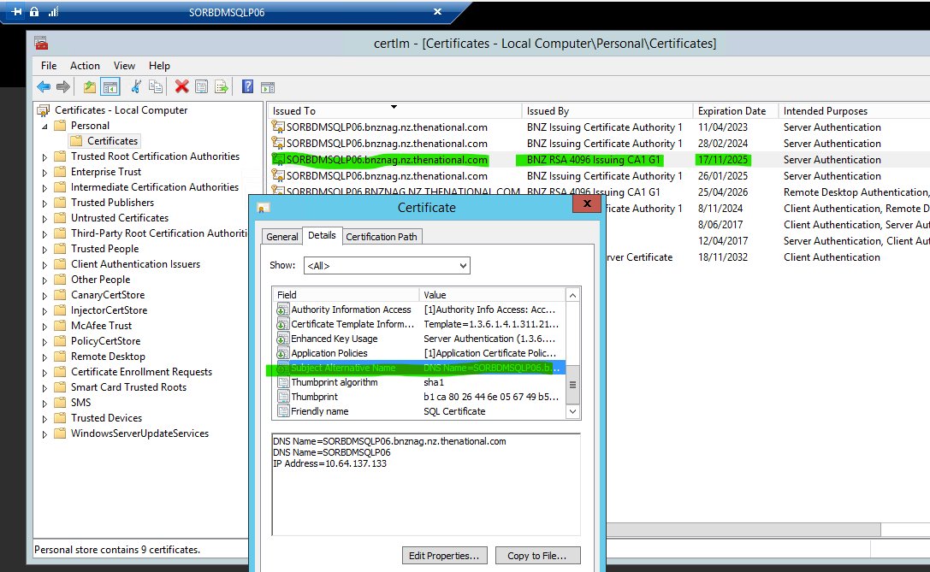

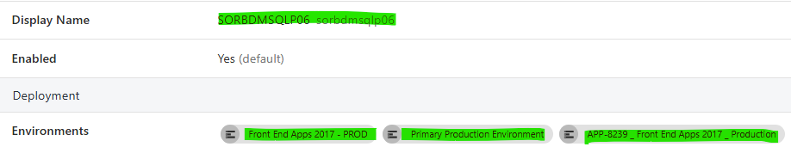

**After Release**

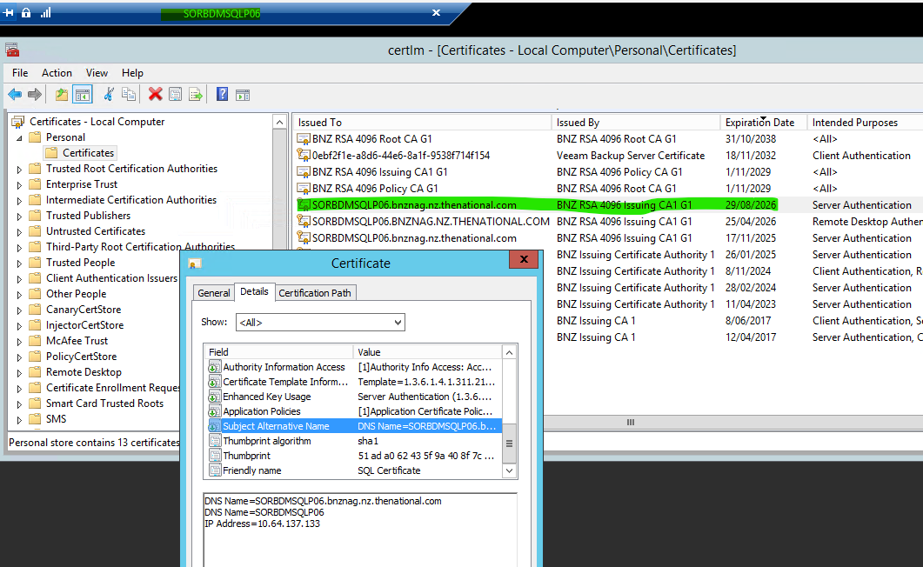

**SETTDMSQLP26.bnznag.nz.thenational.com Certificate Expiring in 90 Days**

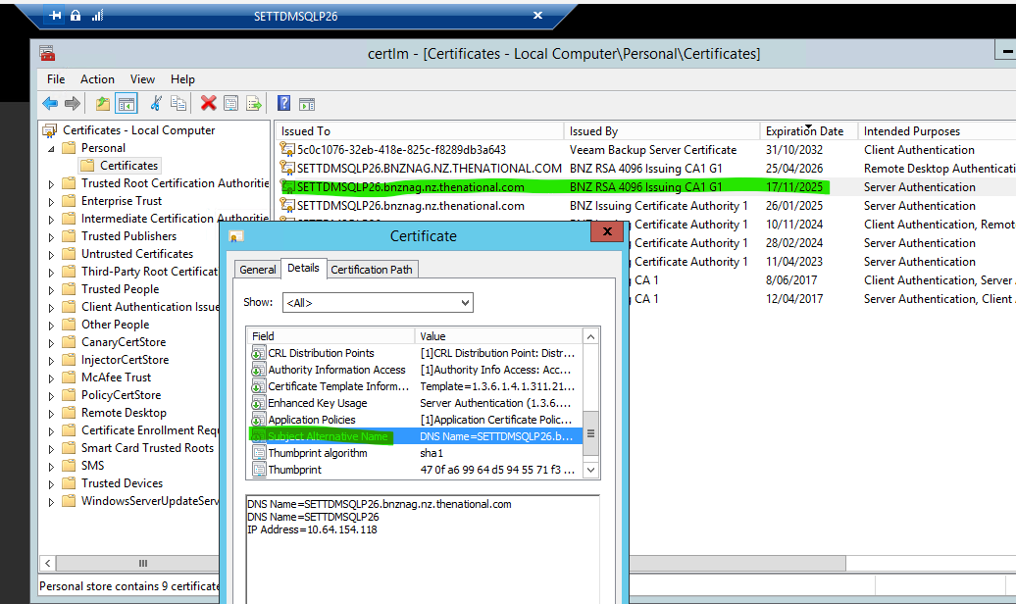

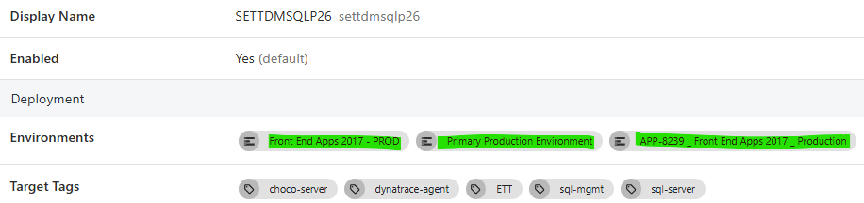

**After Release**

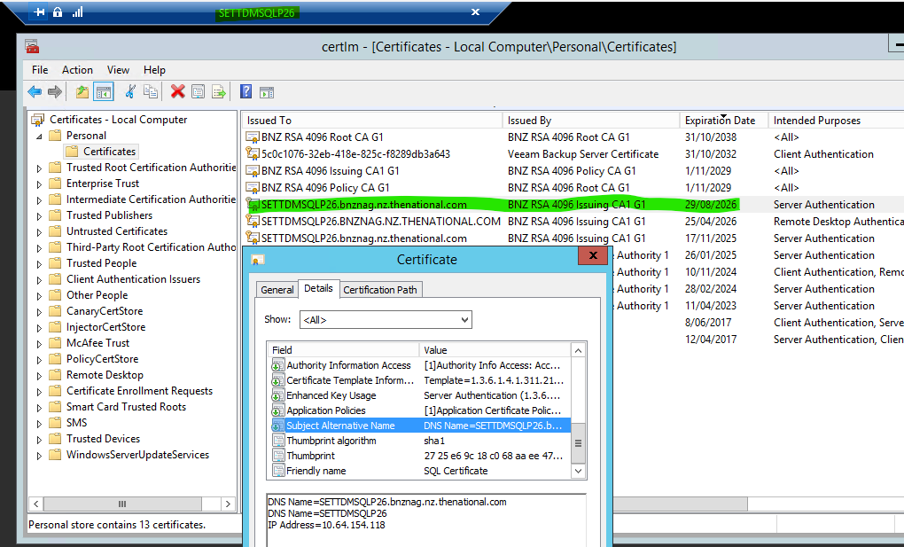

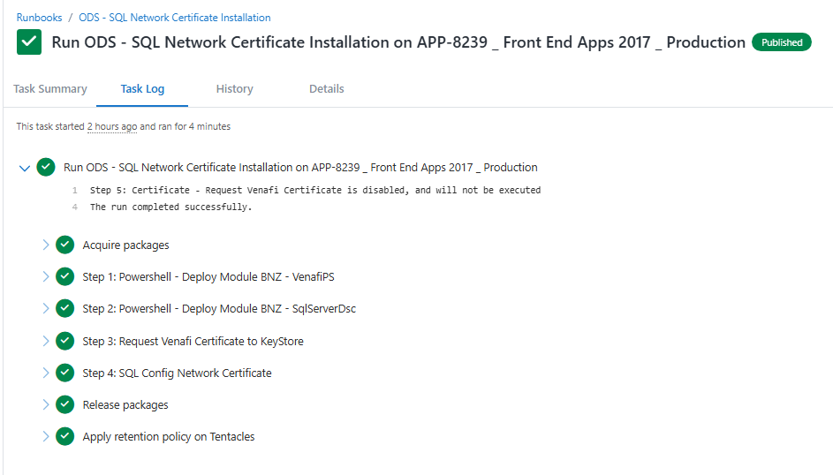

SAKLDMSQLQ05.bnznag.nz.thenational.com Certificate Expiring in 90 Days

<https://jira.nz.thenational.com/browse/DASD-2789>  
**HS Apps 2014 – PPTE | Primary Pre-Production Environment**

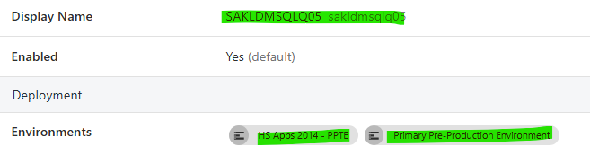

**Before Release**

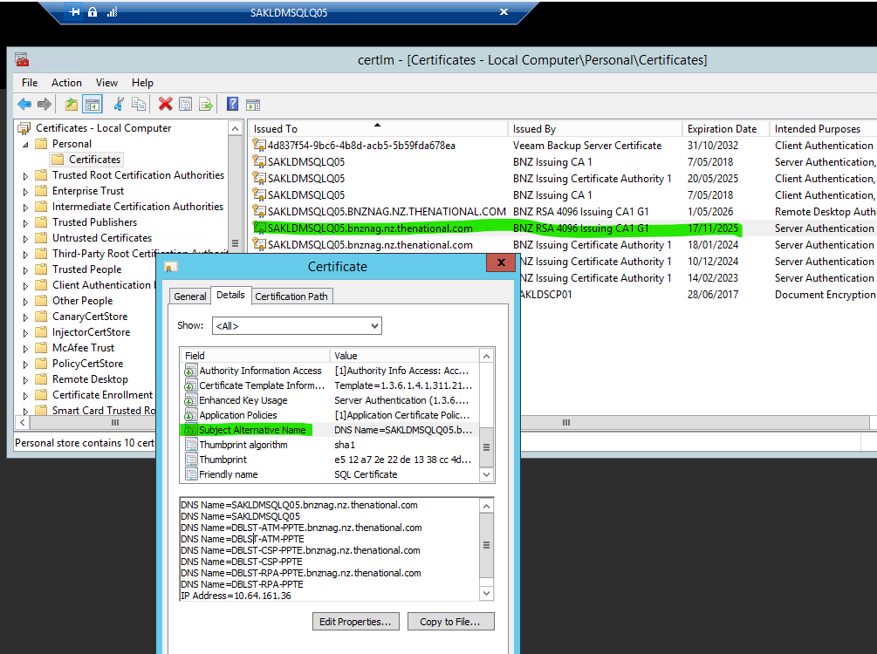

<https://jira.nz.thenational.com/browse/DASD-2790>

FW: SAKLDMSQLQ25.bnznag.nz.thenational.com Certificate Expiring in 90 Days

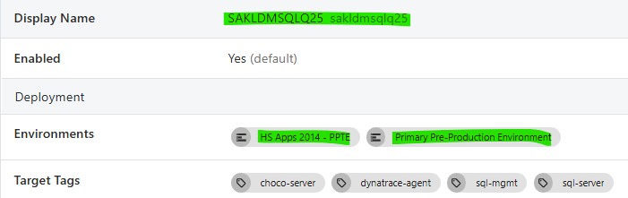

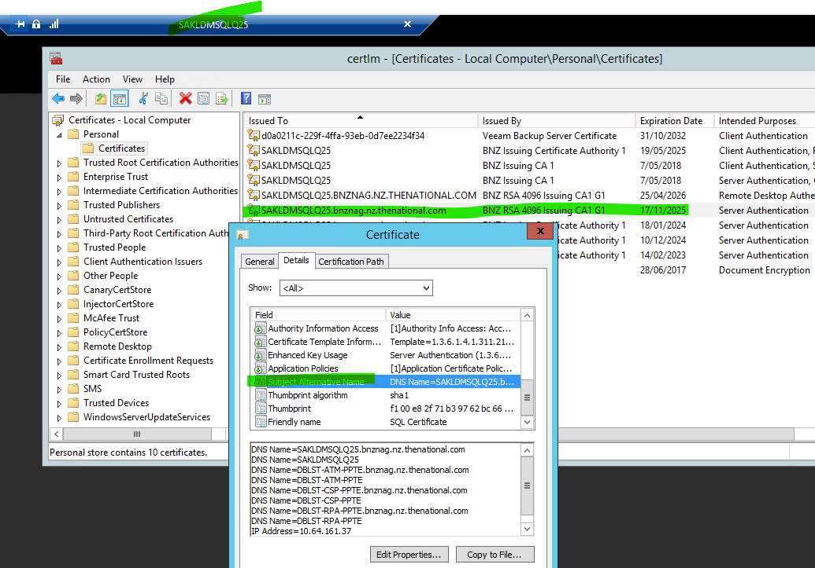

Hey I found a discrepancy in the previous one... check out



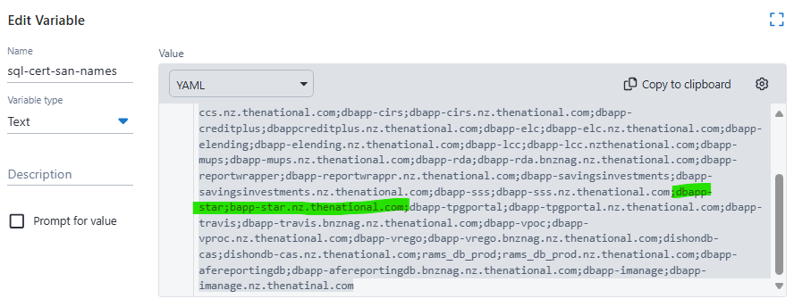

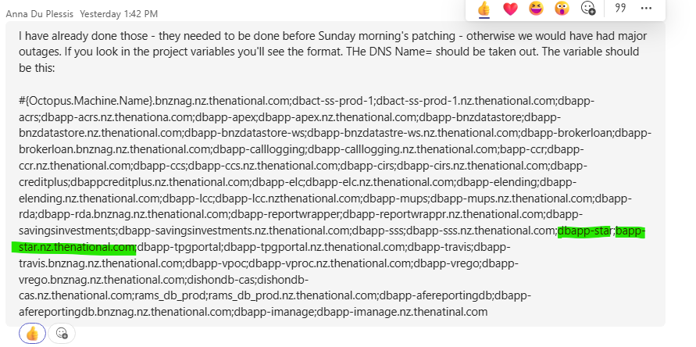

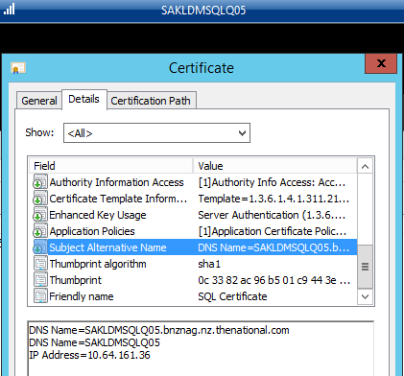

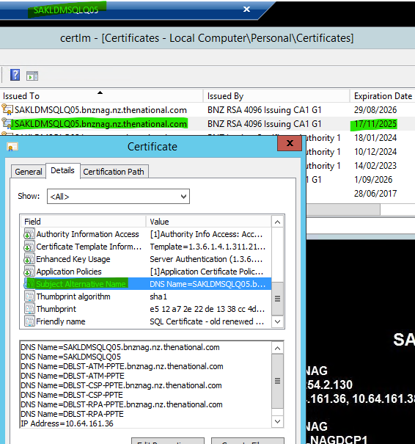

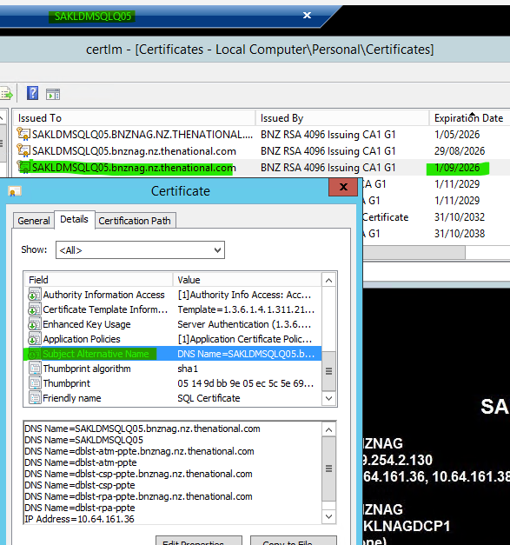

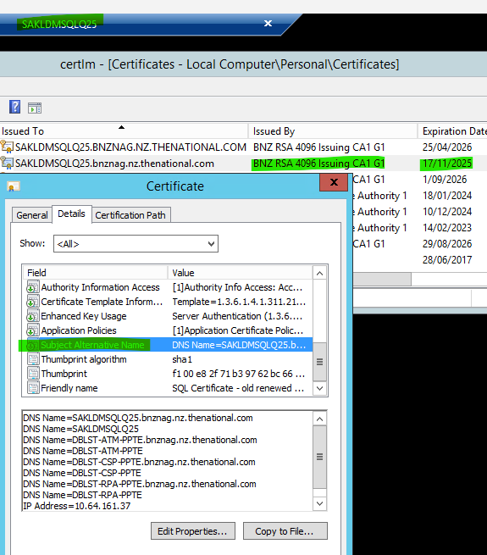

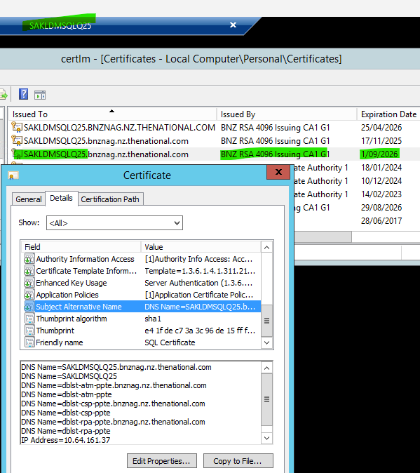

**SETTDMSQLQ28 is DISABLED in Octopus**

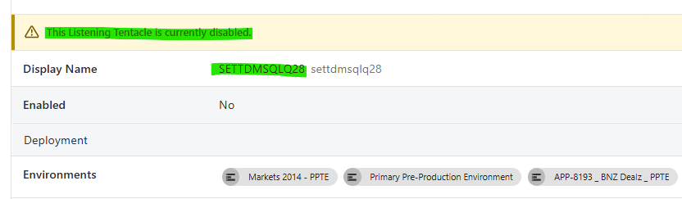

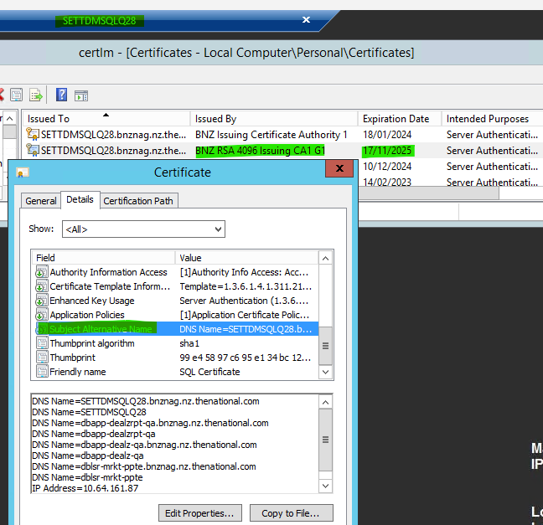

DNS Name=SETTDMSQLQ28.bnznag.nz.thenational.com

DNS Name=SETTDMSQLQ28

DNS Name=dbapp-dealzrpt-qa.bnznag.nz.thenational.com

DNS Name=dbapp-dealzrpt-qa

DNS Name=dbapp-dealz-qa.bnznag.nz.thenational.com

DNS Name=dbapp-dealz-qa

DNS Name=dblsr-mrkt-ppte.bnznag.nz.thenational.com

DNS Name=dblsr-mrkt-ppte

IP Address=10.64.161.87

**SETTDMSQLT09 is DISABLED in Octopus**

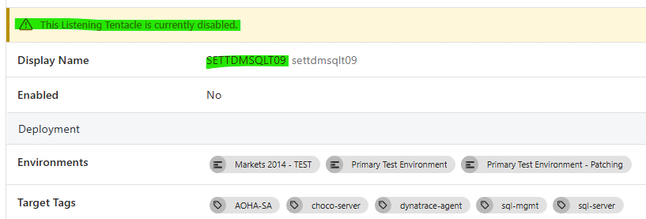

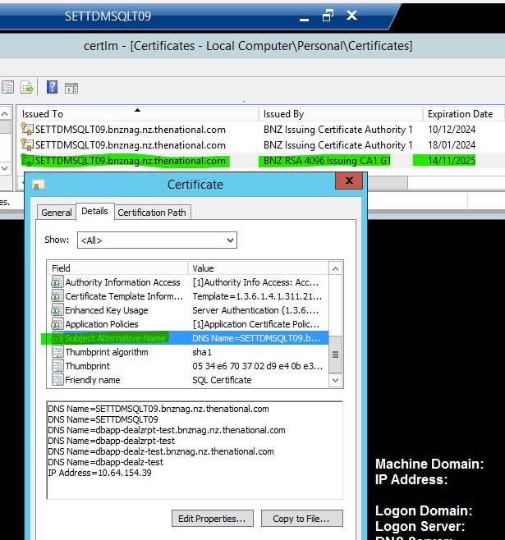

DNS Name=SETTDMSQLT09.bnznag.nz.thenational.com

DNS Name=SETTDMSQLT09

DNS Name=dbapp-dealzrpt-test.bnznag.nz.thenational.com

DNS Name=dbapp-dealzrpt-test

DNS Name=dbapp-dealz-test.bnznag.nz.thenational.com

DNS Name=dbapp-dealz-test

IP Address=10.64.154.39

**SETTDMSQLQ09 is DISABLED in Octopus**

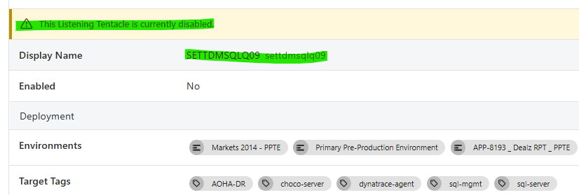

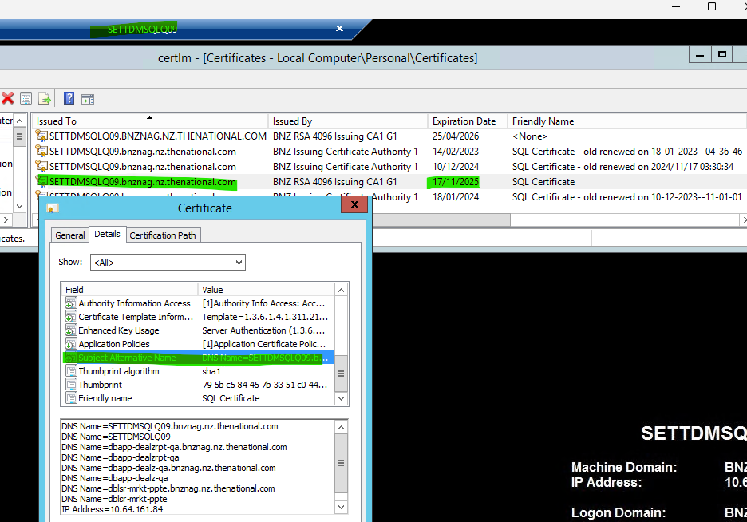

DNS Name=SETTDMSQLQ09.bnznag.nz.thenational.com

DNS Name=SETTDMSQLQ09

DNS Name=dbapp-dealzrpt-qa.bnznag.nz.thenational.com

DNS Name=dbapp-dealzrpt-qa

DNS Name=dbapp-dealz-qa.bnznag.nz.thenational.com

DNS Name=dbapp-dealz-qa

DNS Name=dblsr-mrkt-ppte.bnznag.nz.thenational.com

DNS Name=dblsr-mrkt-ppte

IP Address=10.64.161.84

**SETTDMSQLQ07 is ENABLED in Octopus – 2-9-205**

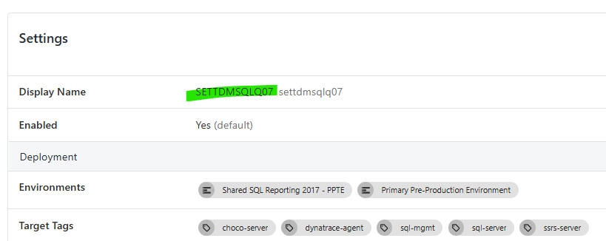

**Shared SQL Reporting 2017 – PPTE**

DNS Name=SETTDMSQLQ07.bnznag.nz.thenational.com

DNS Name=SETTDMSQLQ07

DNS Name=dbapp-crs-ppte.bnznag.nz.thenational.com

DNS Name=dbapp-crs-ppte

IP Address=10.64.155.10

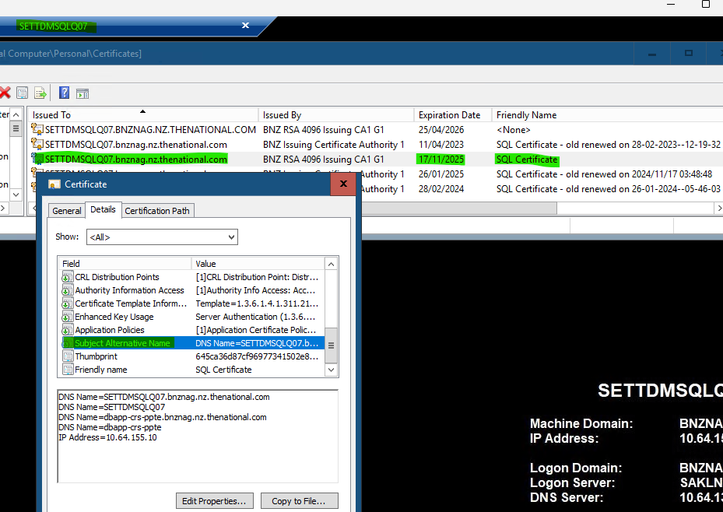

**After Installation…**

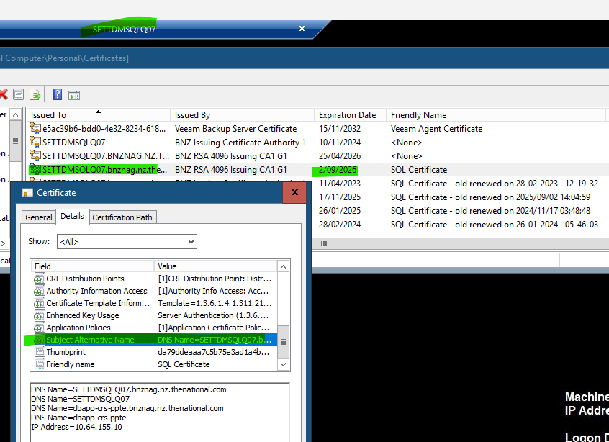

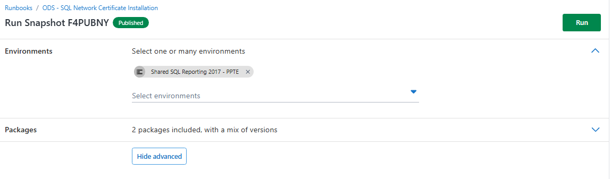

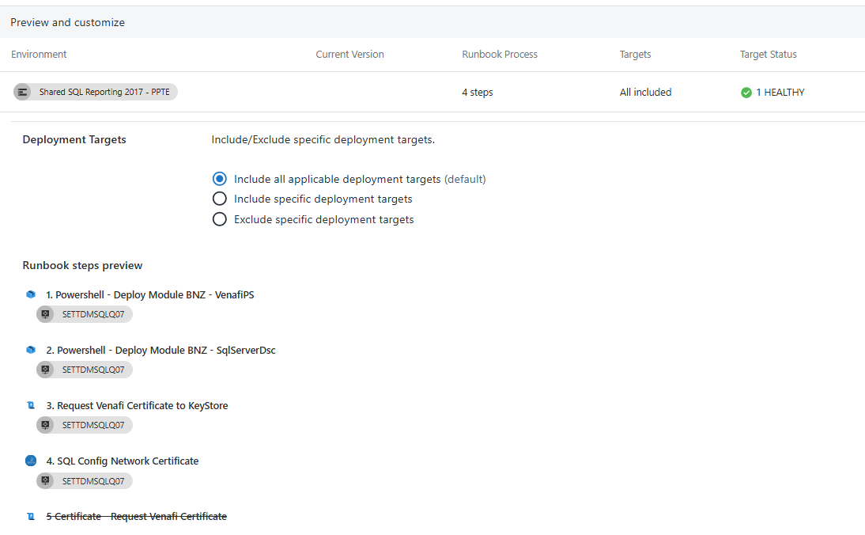

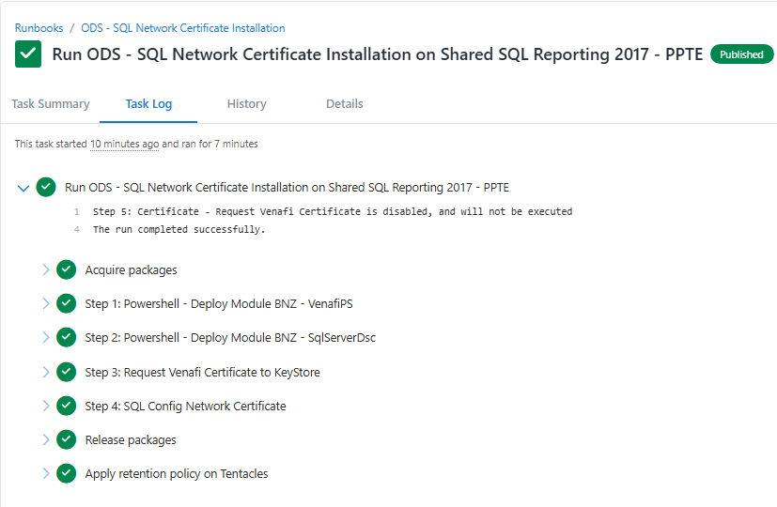

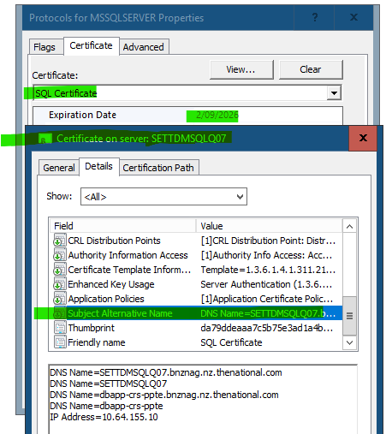

**10-09-2025**

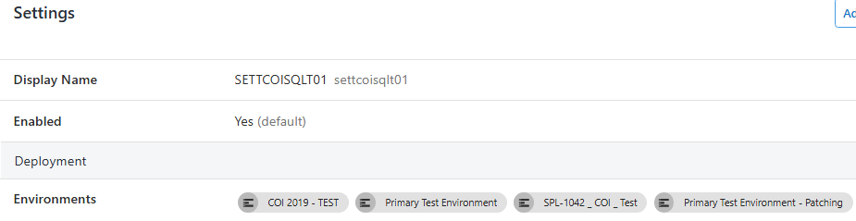

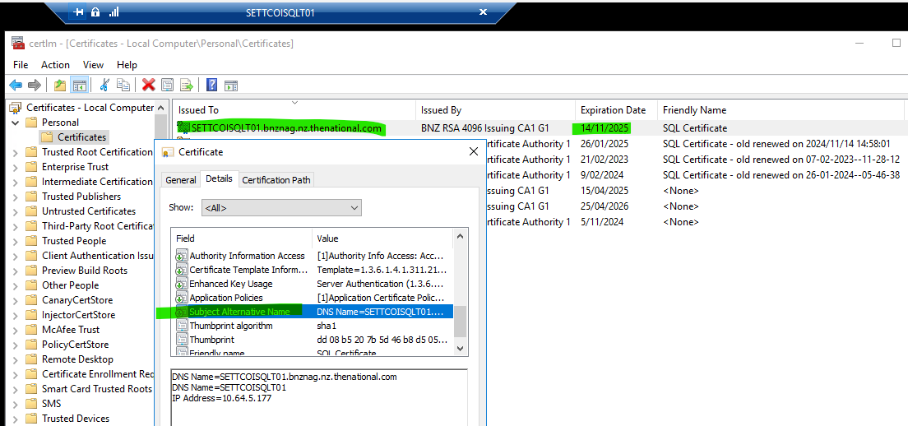

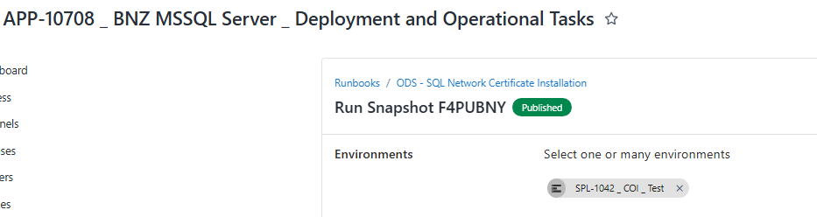

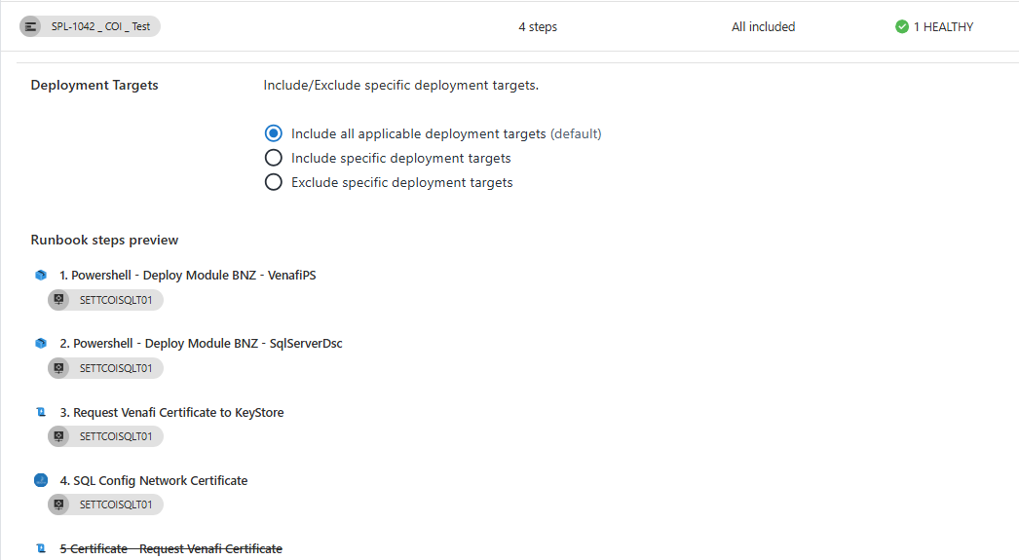

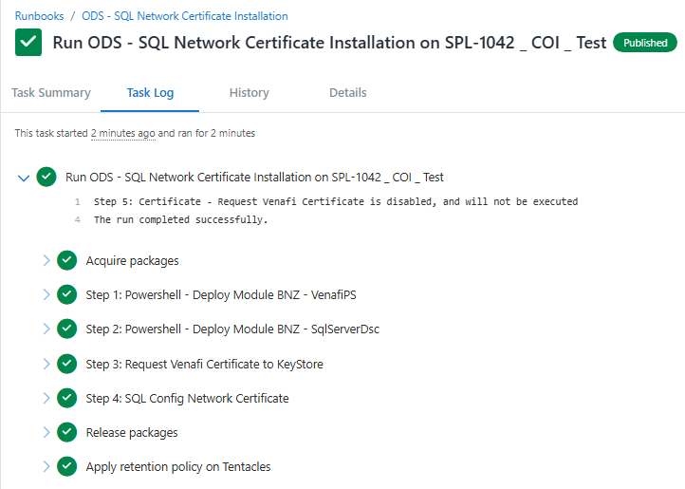

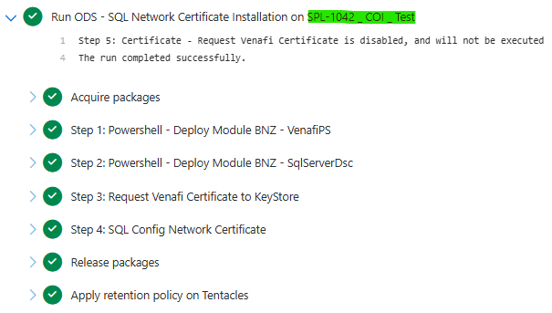

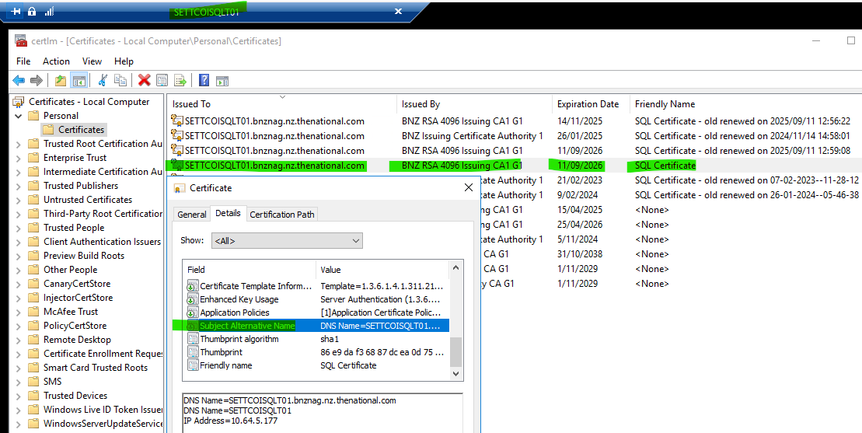

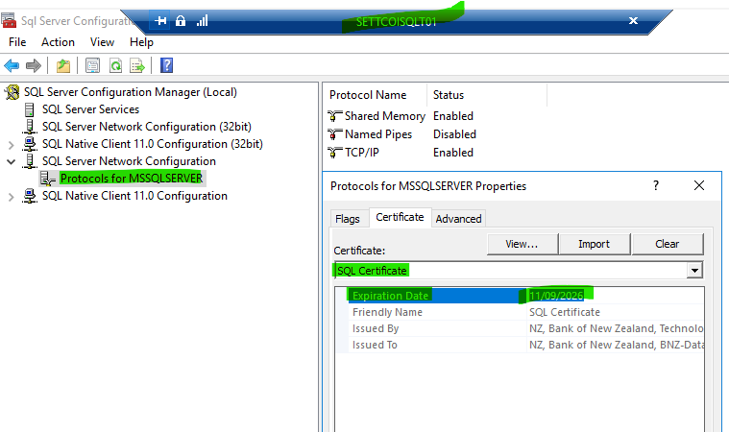

**SWLGDMSQLT01.bnznag.nz.thenational.com Certificate Expiring in 60 Days**

[Projects - Octopus Deploy](https://octopus-os/app#/Spaces-322/projects?page=1&pageSize=50)

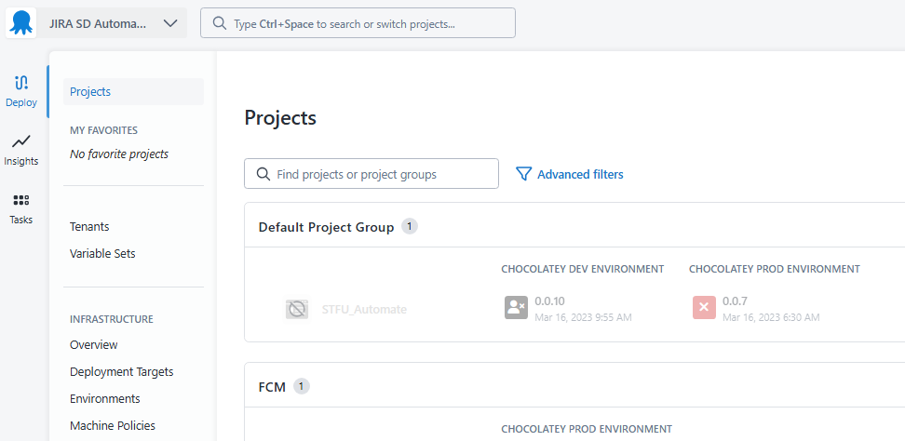

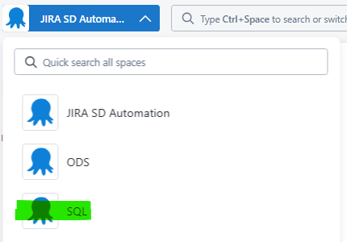

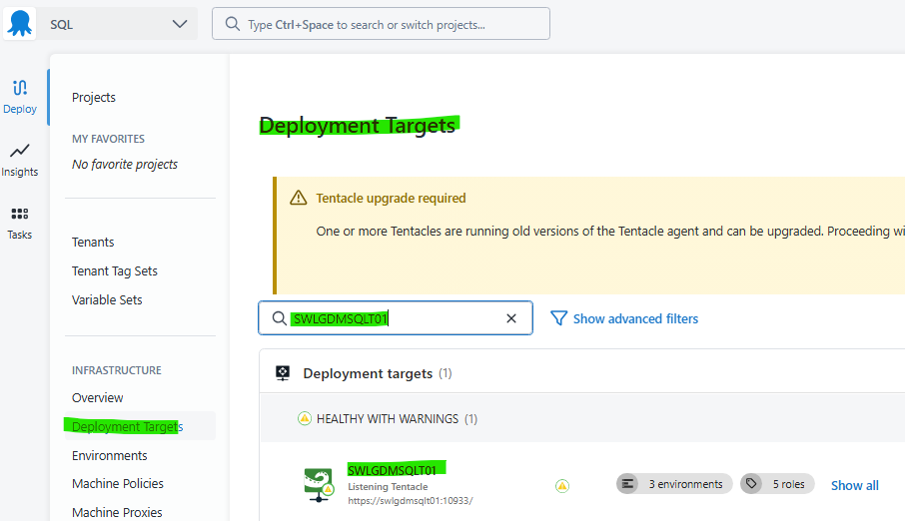

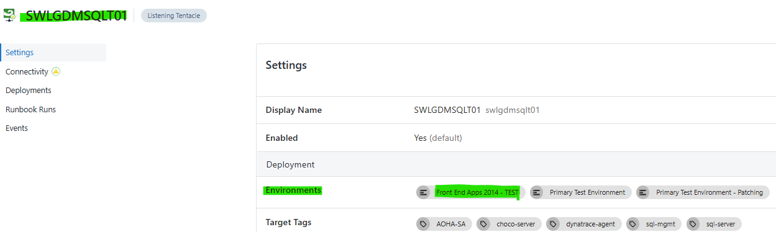

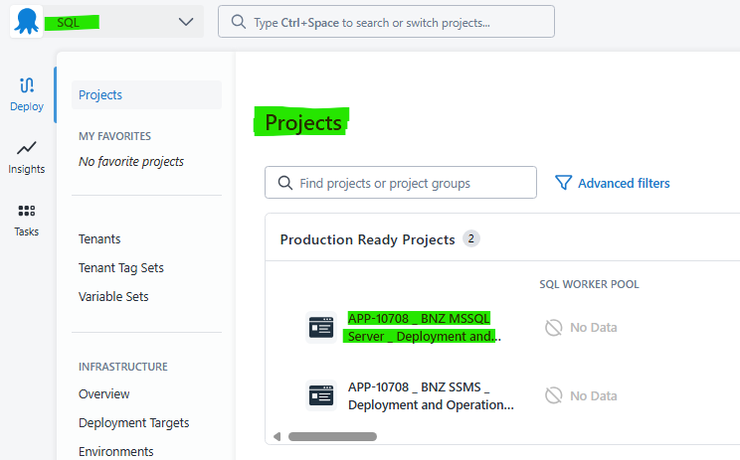

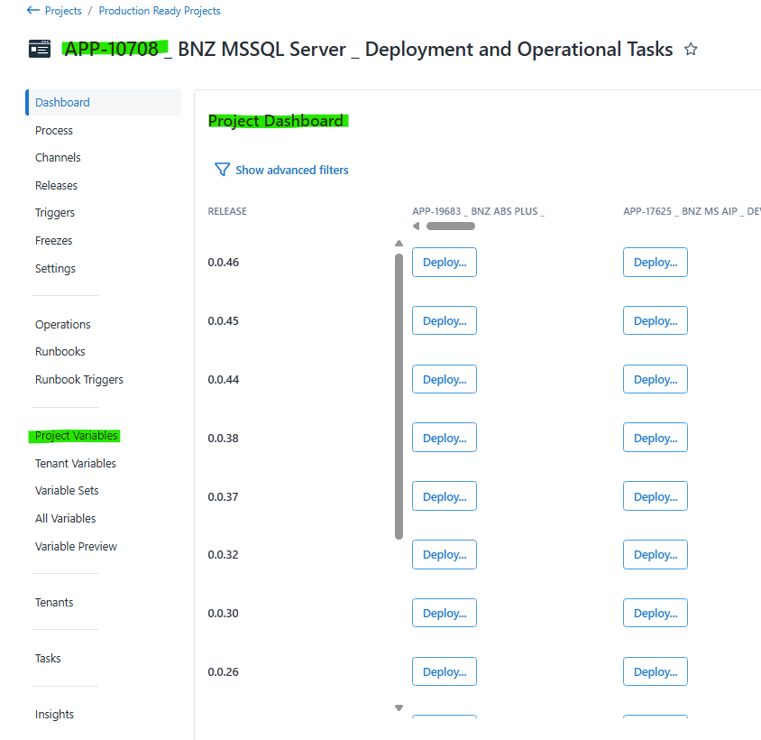

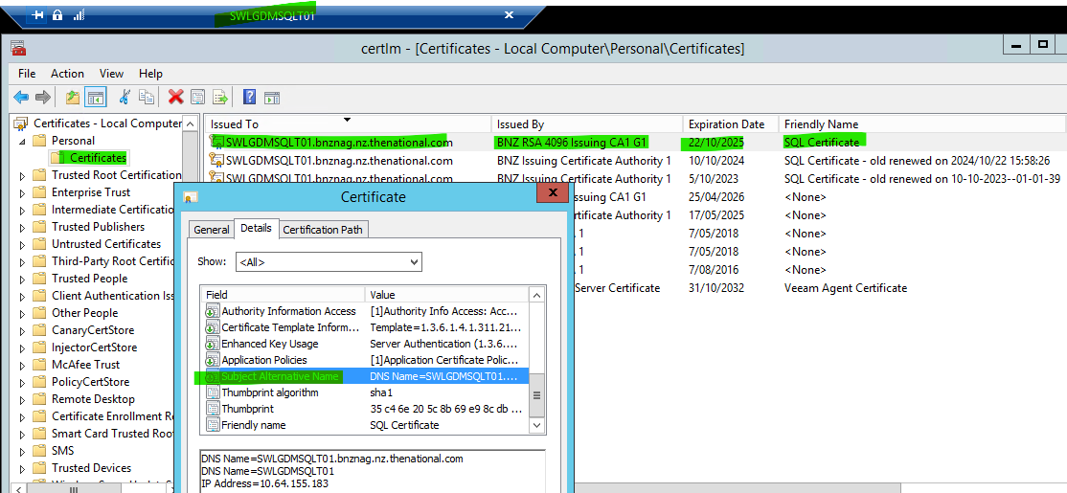

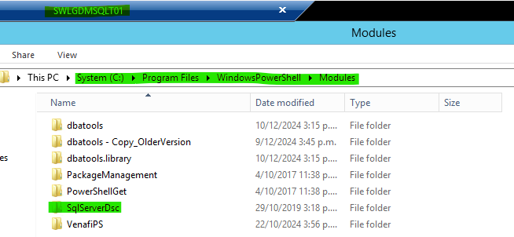

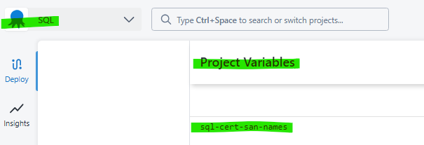

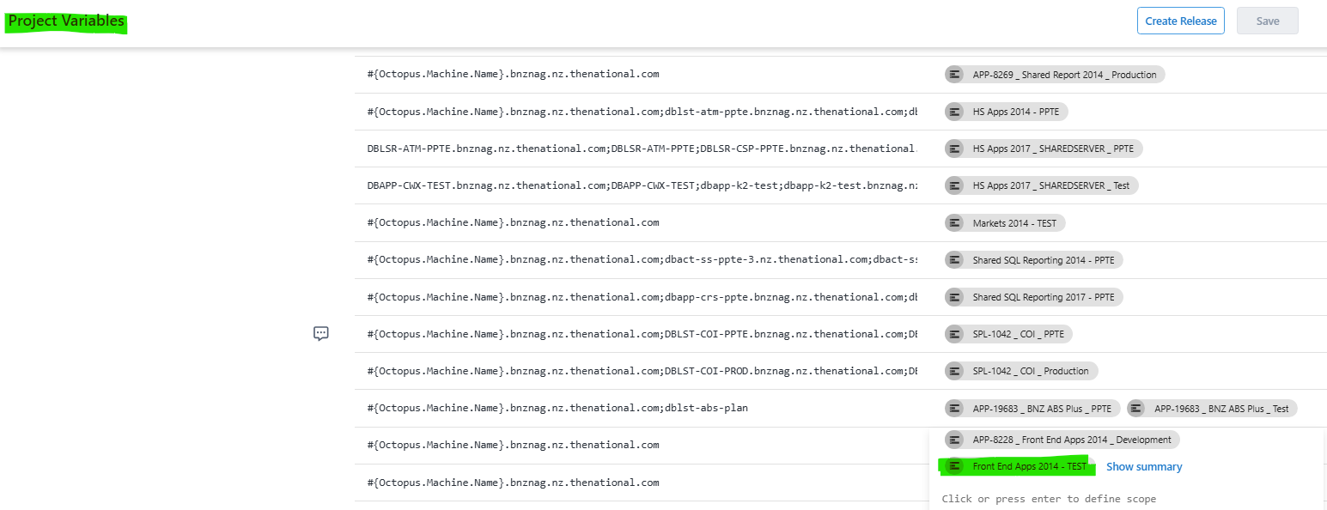

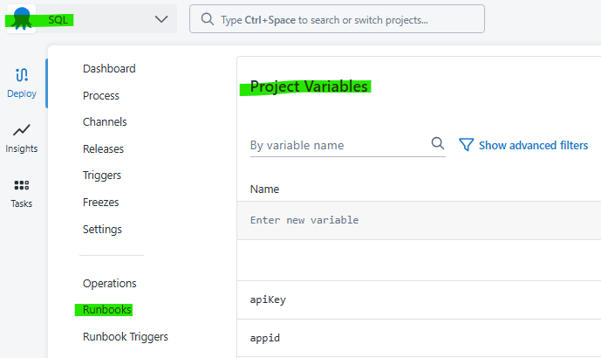

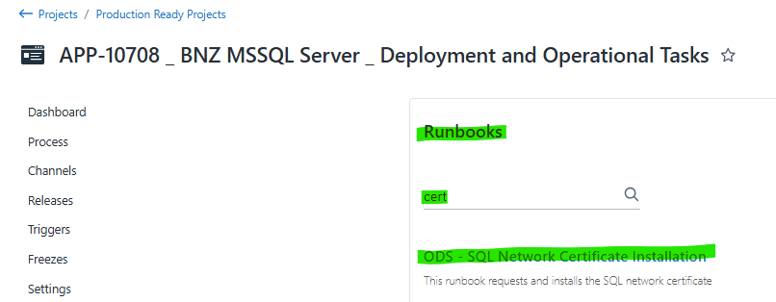

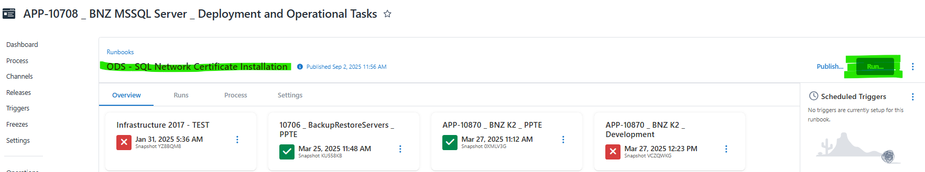

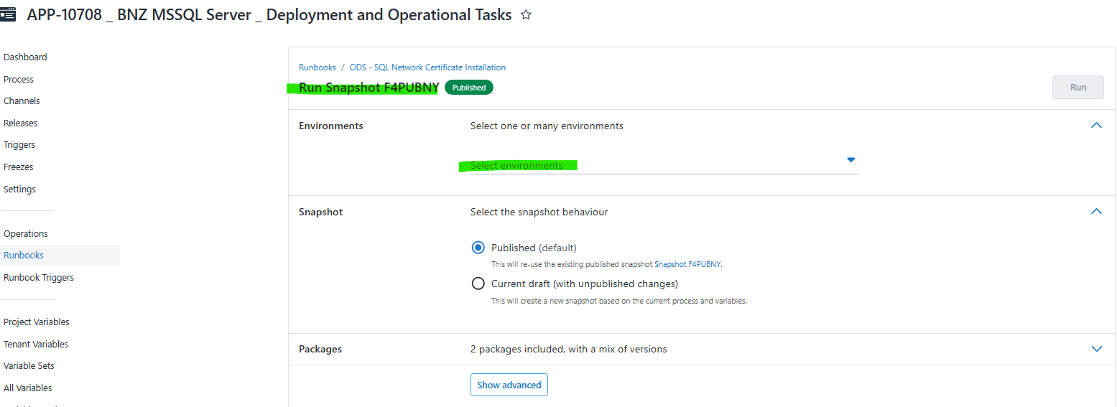

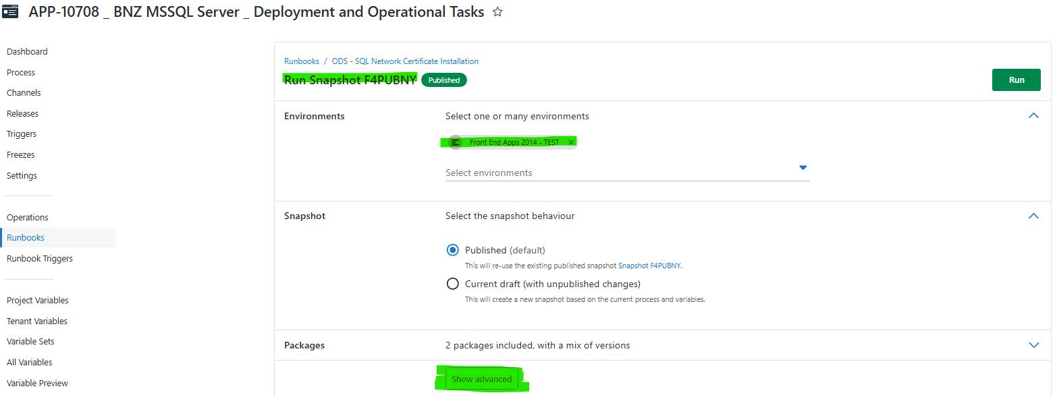

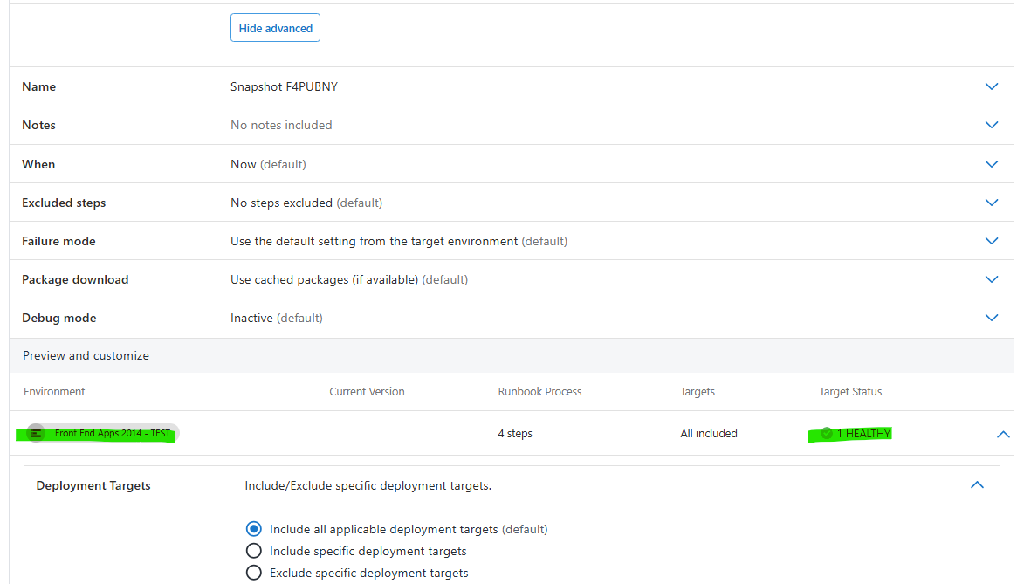

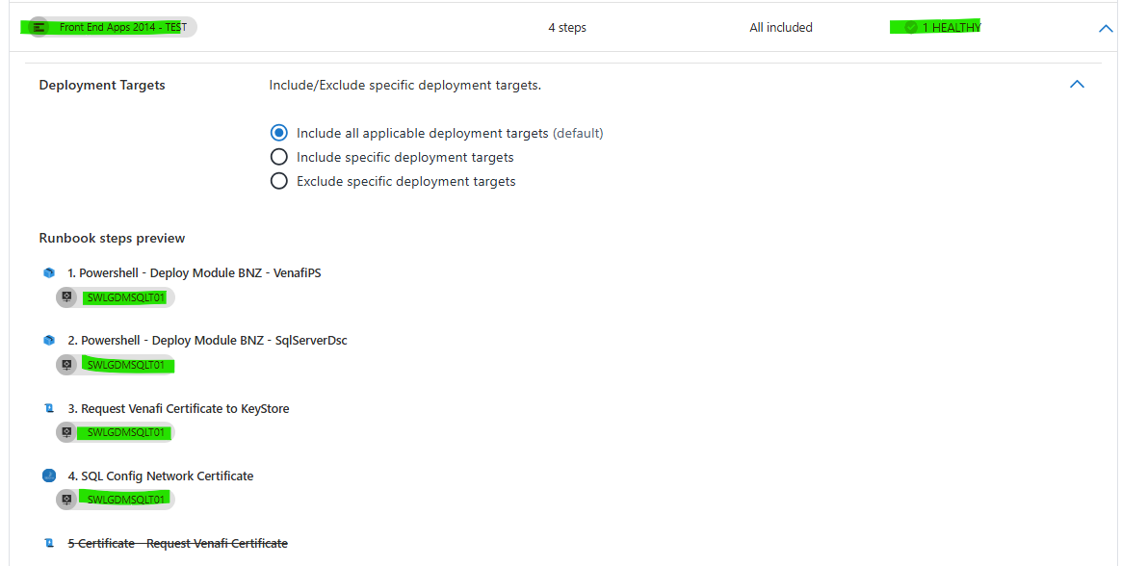

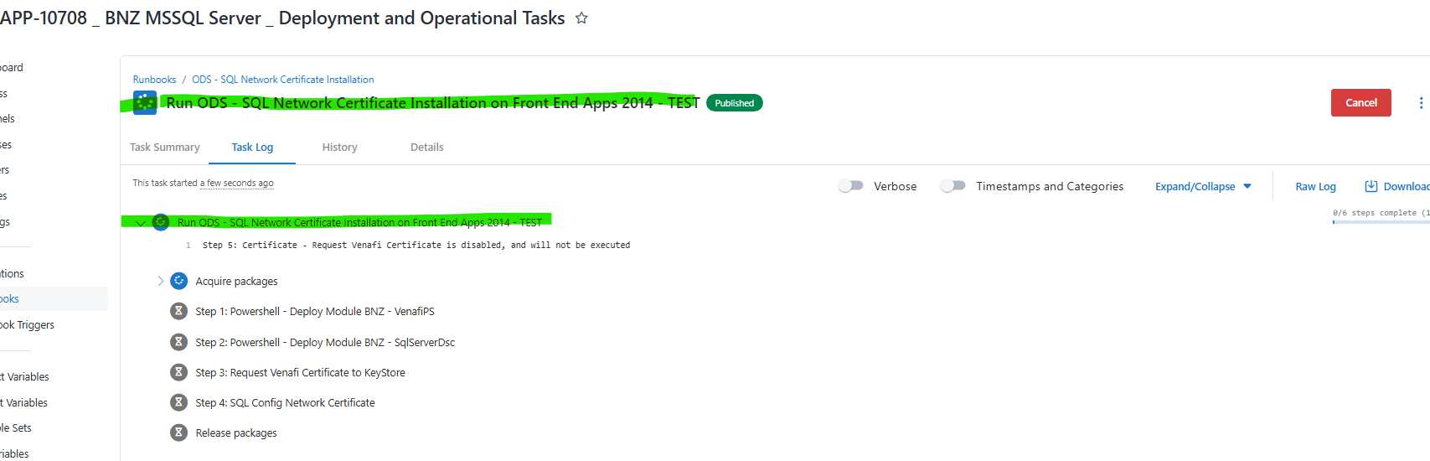

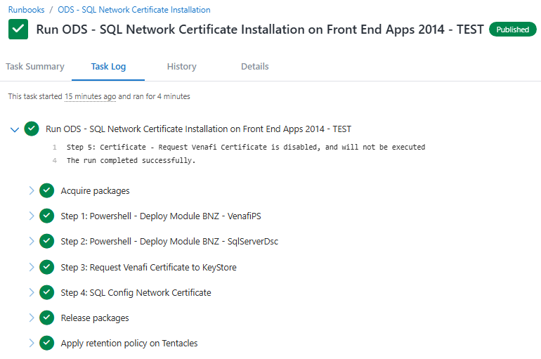

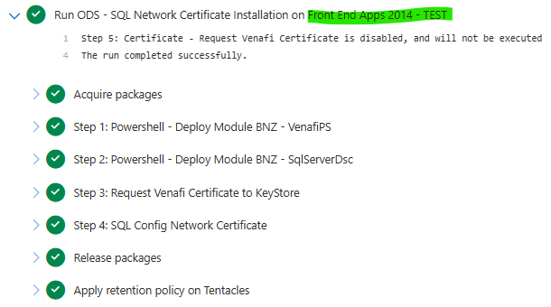

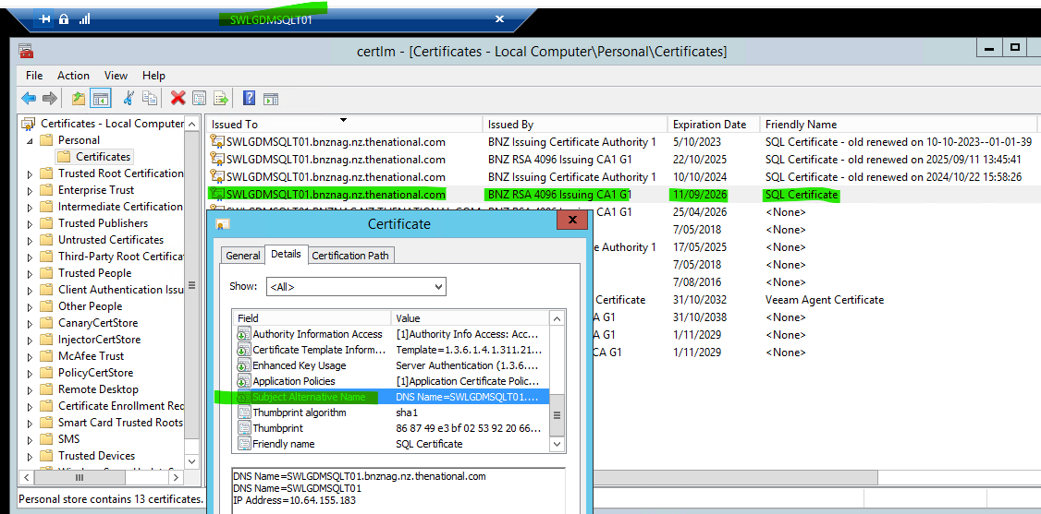

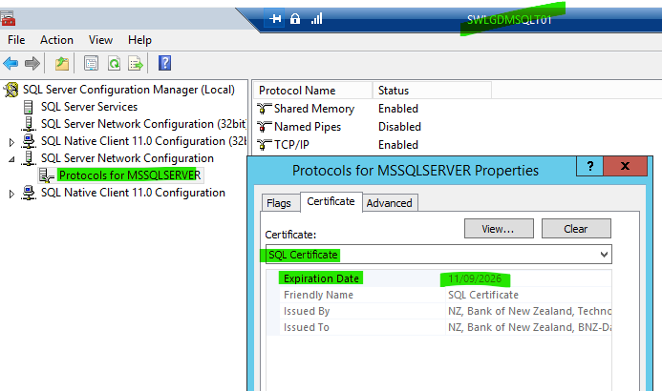

**DASD 2908 – SQL - Database Decommission**

* **Test Environemnt = SAKLDMSQLT04**

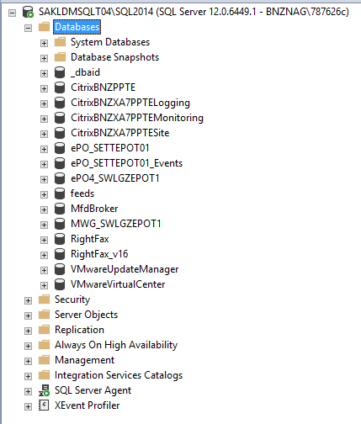

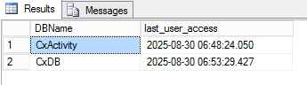

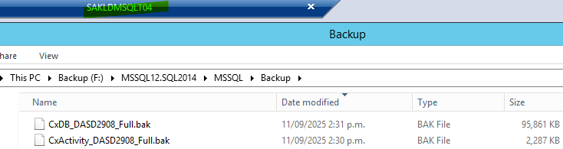

**Prod Environment = SAKLDMSQLP04**

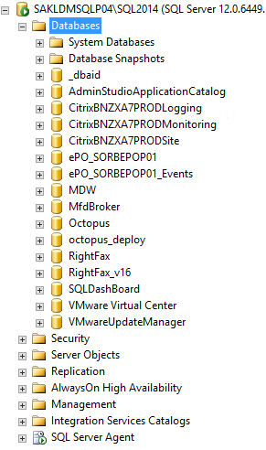



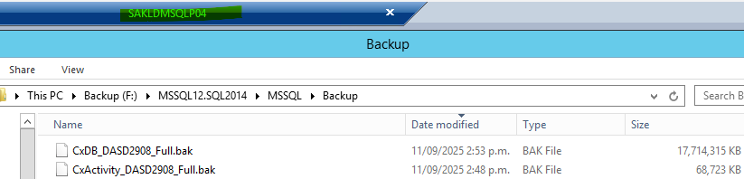

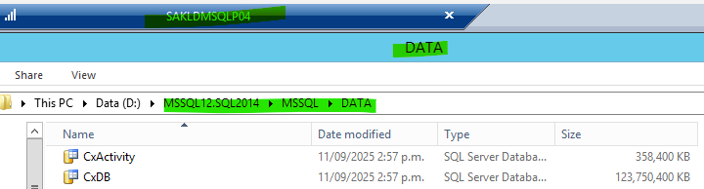

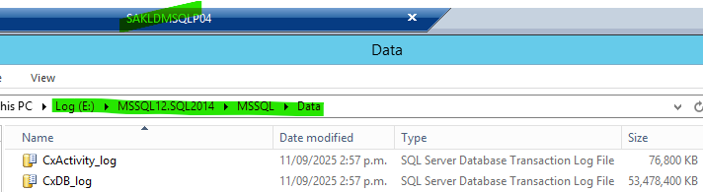

**SETTDMSQLT07.bnznag.nz.thenational.com Certificate Expiring in 90 Days**

**https://jira.nz.thenational.com/browse/DASD-2879**

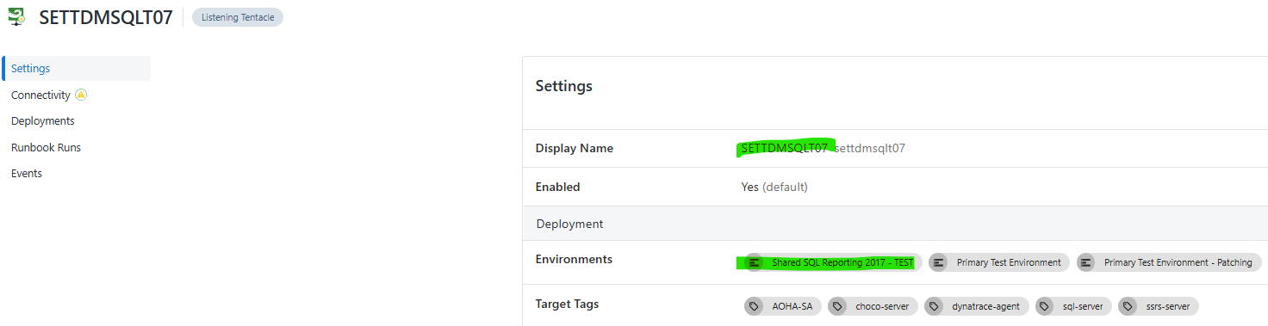

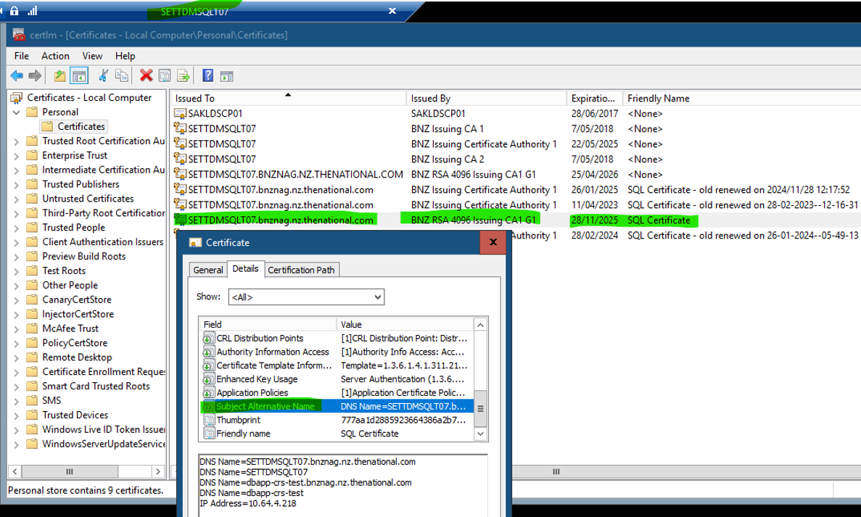

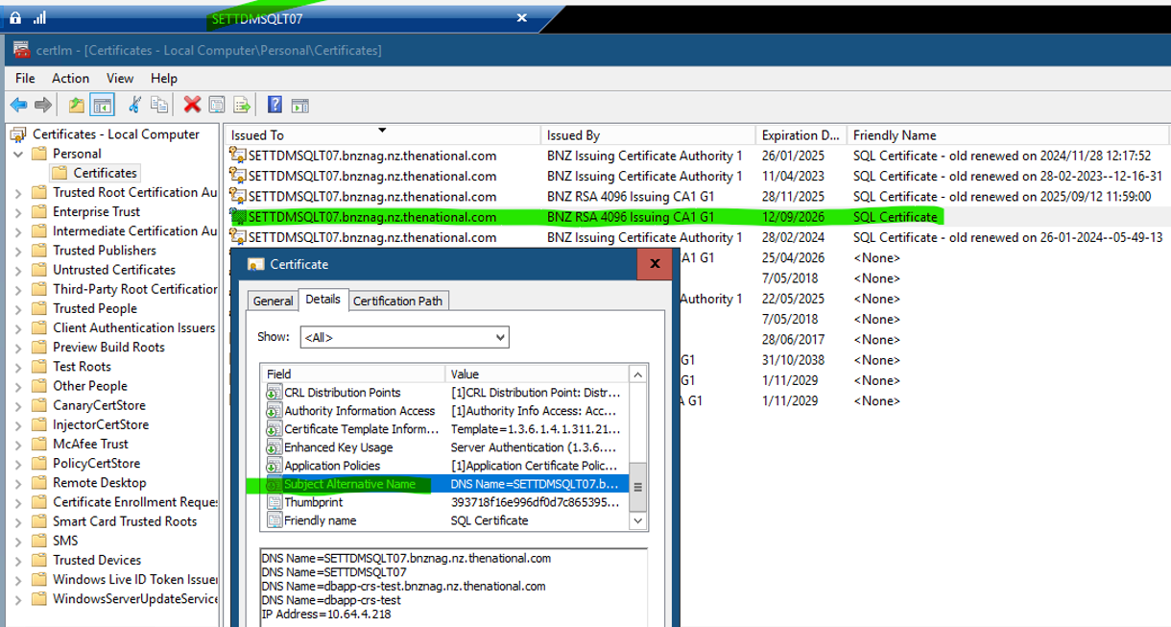

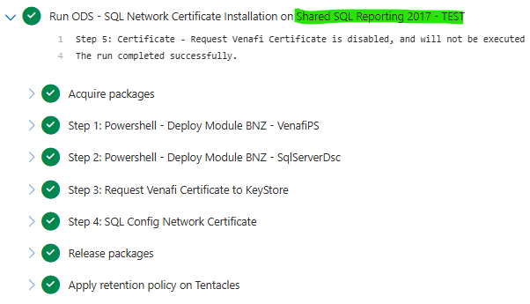

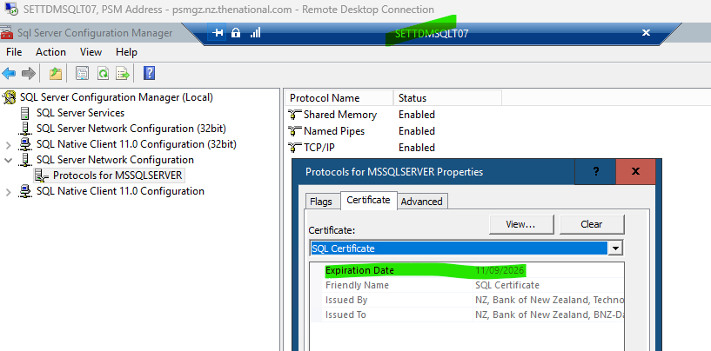

**SETTSPSQLT01.bnznag.nz.thenational.com Certificate Expiring in 90 Days**

**- https://jira.nz.thenational.com/browse/DASD-2880**

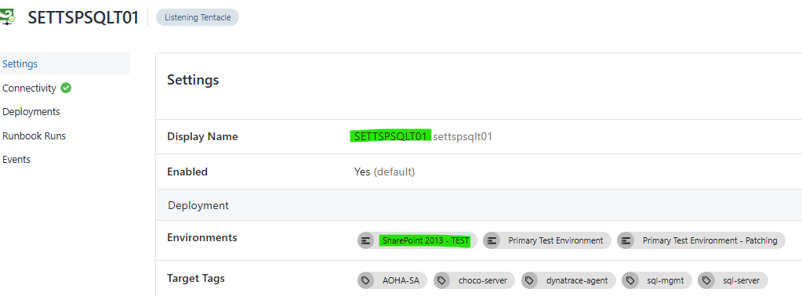

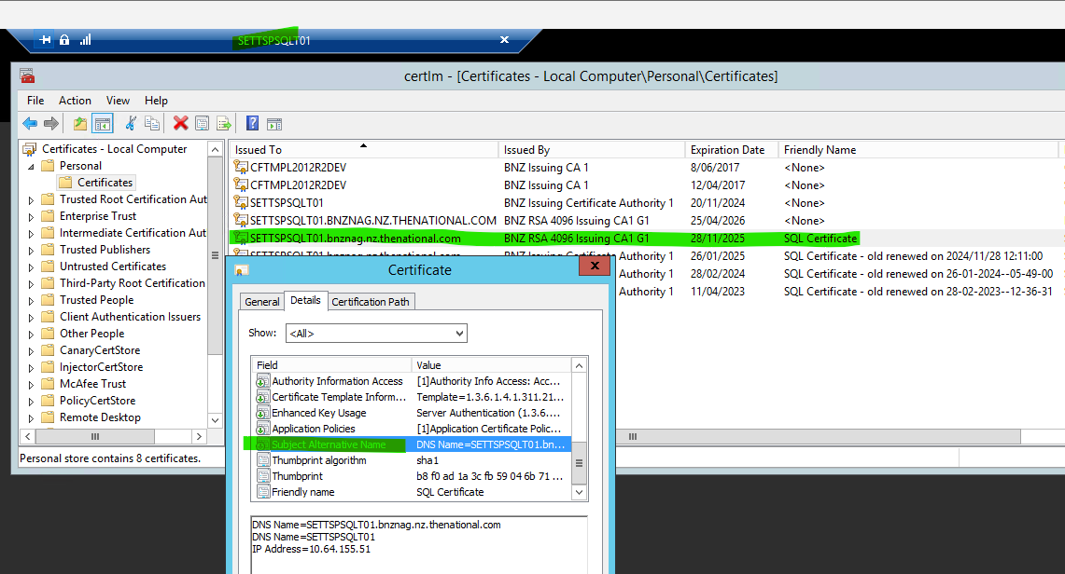

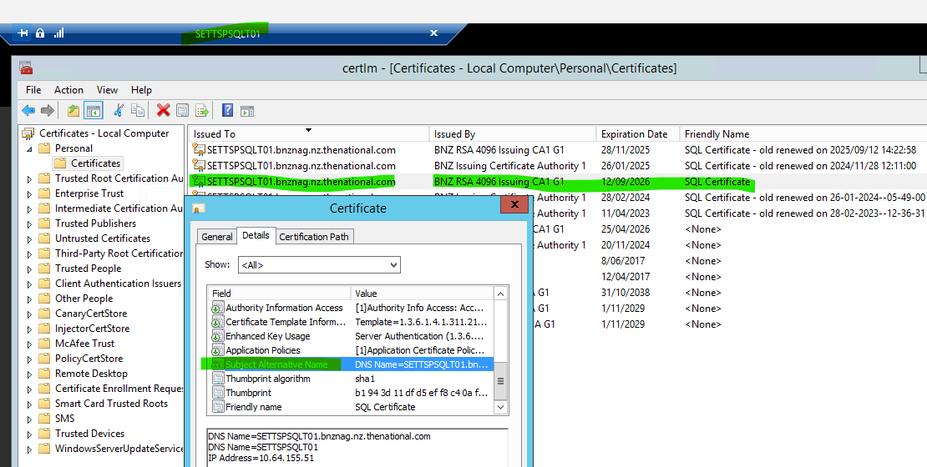

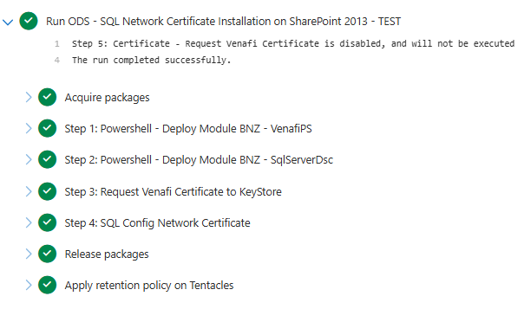

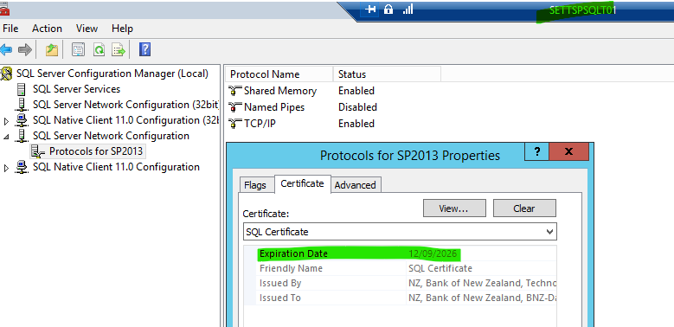

**17Sept 2025**

<https://jira.nz.thenational.com/browse/ESAP-4971>

**Decommission non-prod databases, sql agent job & ssrs report**

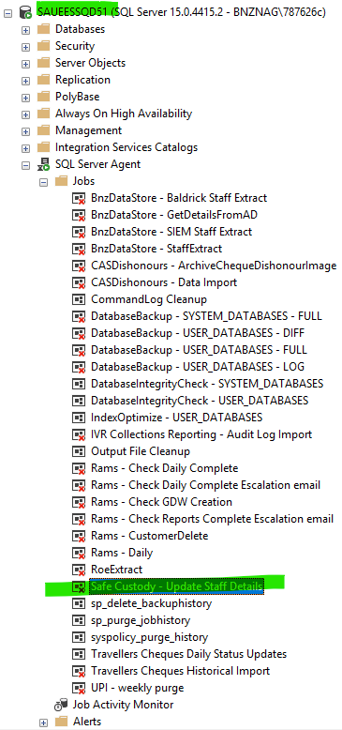

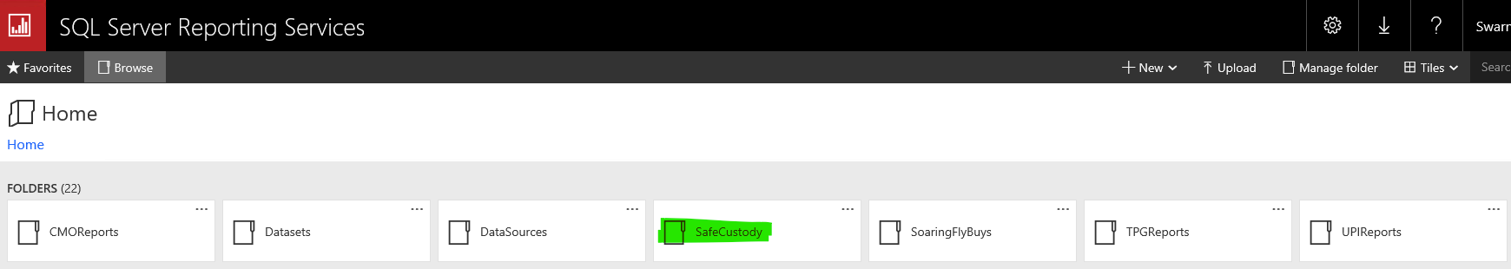

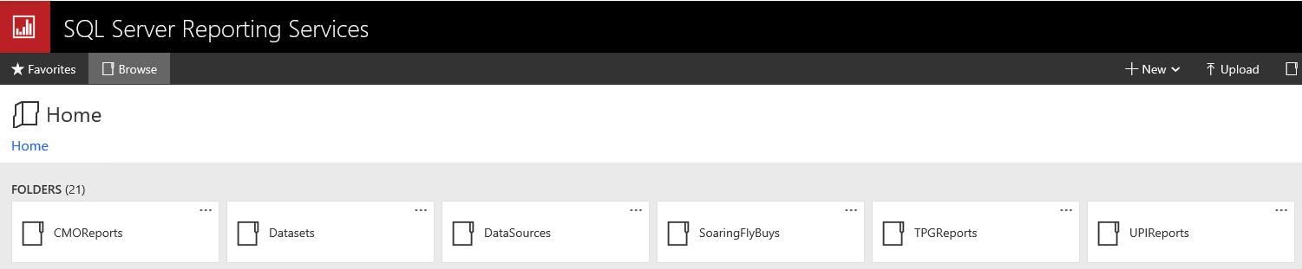

**CTASK2661859 - Decommission Instinct Database and SQL SSRS/SSIS Job – 17 Sept 2025**

https://jira.nz.thenational.com/browse/DASD-2974

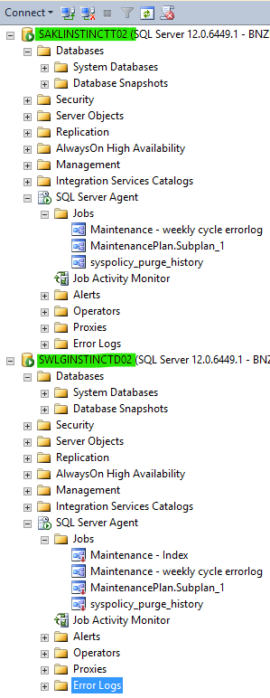

22 Sept 2025

<https://jira.nz.thenational.com/browse/DASD-2977>

FW: SETTDMSQLT09.bnznag.nz.thenational.com Certificate Expiring in 60 Days

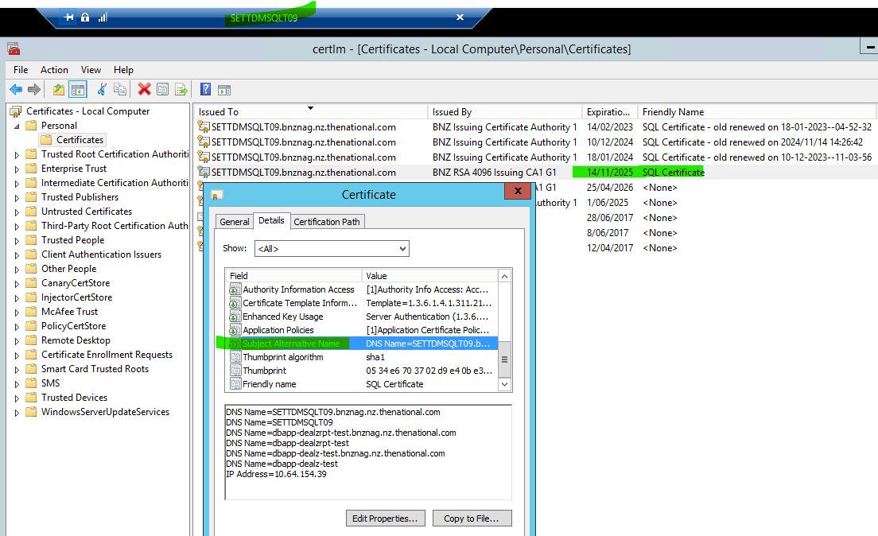

DNS Name=SETTDMSQLT09.bnznag.nz.thenational.com

DNS Name=SETTDMSQLT09

DNS Name=dbapp-dealzrpt-test.bnznag.nz.thenational.com

DNS Name=dbapp-dealzrpt-test

DNS Name=dbapp-dealz-test.bnznag.nz.thenational.com

DNS Name=dbapp-dealz-test

IP Address=10.64.154.39

**15 Oct 2025 - https://jira.nz.thenational.com/browse/DASD-3197**

